Title - Simulation of a Digital Twin Based Battery Management System for Real-Time Monitoring Using Enhanced State Prediction and Fault Analysis Algorithms.

Project Understanding

1. Introduction: The Critical Need for Advanced Battery Management
In the modern era of engineering, the global shift towards electrification has made energy storage a cornerstone technology. From powering Electric Vehicles (EVs) and stabilizing EV charging stations to storing energy from renewable sources like solar plants, batteries are ubiquitous and essential for operation. The performance, safety, and lifespan of these battery systems are managed by a Battery Management System (BMS).
Traditionally, BMS development relies heavily on either pure software simulation or extensive hardware testing.
- Pure Simulation (e.g., MATLAB, ANSYS): While powerful for solving complex problems and addressing research gaps early on, simulations cannot capture the real-time, unpredictable nature of a physical battery's behavior, such as sudden temperature changes or manufacturing inconsistencies.
- Pure Hardware Development: Building and testing physical battery packs is time-consuming, expensive, and lacks the flexibility to quickly test thousands of "what-if" scenarios.
Therefore, a significant research gap exists in creating a development environment that combines the best of both worlds: the predictive power of simulation with the real-world fidelity of hardware.
2. Project Concept: The Digital Twin Approach
The core concept of this research is to bridge this gap by developing a Digital Twin (DT) of a multi-bank Lithium-Ion battery pack. A Digital Twin is a virtual replica of a physical system that is continuously updated with real-time data from its physical counterpart.
Our approach is not just to build a simulation, but to create a bi-directional, learning system:
- Virtual Replication: We build a detailed simulation of our battery pack in MATLAB.
- Real-Time Data Integration: We build a physical hardware setup of the same battery pack. Data from this hardware—like voltage, current, and temperature of individual cells—is fed into the MATLAB simulation in real-time.
- Parallel Processing & Comparison: The simulation runs in parallel with the physical system. Its behavior is constantly compared against the hardware data.
- Intelligent Refinement (AI/ML): Any discrepancy between the simulation and the hardware is analyzed using Machine Learning algorithms. This allows the simulation model to learn and correct itself, becoming a more and more accurate representation of the physical battery over time.
- Advanced Optimization: To push the boundaries of accuracy and speed, we will process the data using a novel approach. This integrated approach makes the BMS significantly more accurate, adaptable, and intelligent, leading to better performance, enhanced safety, and a longer lifespan for the battery system.
3. Project Novelty and Patentability
The key innovative step in this project is the closed-loop integration and comparison of three distinct technological layers for a multi-bank battery system:
- Layer 1: Physical Hardware & Virtual Simulation (The Digital Twin Foundation): Establishing a real-time data link between a physical multi-module battery pack and its MATLAB Simulink model.
- Layer 2: AI/ML for Model Refinement: Using the hardware data not just for display, but to actively train and correct the simulation model for more accurate State of Charge (SOC) and State of Health (SOH) prediction.
- Layer 3: Comparison: Implementing and comparing a next-generation classical AI/ML methods for battery parameter estimation, a novel approach in this domain.
This multi-layered, comparative methodology, all within a single cohesive system for real-time monitoring and health prediction, forms the core of the intellectual property and the novelty of this research.
4. Detailed Methodology and System Architecture
The project workflow is divided into interconnected modules:
Module A: Simulation Development (The Virtual Twin in MATLAB)
- Power Conversion Stages: A MATLAB model is created for an AC-to-DC converter followed by a DC-to-DC buck-boost converter. This stage conditions the input power for the load and the battery.
- Load Model: A DC motor model is included to act as a representative load, simulating real-world power demands.
- Multi-Bank Battery Pack Model: The core of the virtual twin is a model of a battery pack. This pack consists of 5 modules. Each module contains 10 individual lithium-ion cells (total 50 cells). Each cell is modeled with unique, variable parameters (voltage range: 3.2V - 3.9V) and different initial States of Charge (SOC) to mimic real-world cell imbalances.
Module B: Hardware Development (The Physical Twin)
- Physical Battery Pack: A hardware setup is built to mirror the simulation design exactly: a physical pack with 5 modules, each containing 10 cells.
- Sensor Array: An array of sensors is installed to measure critical parameters: individual cell voltages, pack current, and temperature at multiple points within the pack.
- Data Acquisition System: A microcontroller or data acquisition device (DAQ) collects this sensor data and transmits it to the MATLAB environment on a computer in real-time.
Module C: The Digital Twin Engine & Data Processing (in MATLAB)
- Real-Time Data Ingestion: MATLAB receives the live data stream from the hardware sensors.
- Parallel Simulation Execution: The MATLAB Simulink model of the battery pack runs simultaneously, driven by the same input conditions as the hardware.
- Battery Parameter and SOX Estimation: The incoming hardware data and the simulation results are both fed into MATLAB Function blocks. These blocks contain algorithms to calculate key battery parameters:
  - State of Charge (SOC): How much energy is left in the battery (like a fuel gauge).
  - State of Health (SOH): The overall condition and remaining lifespan of the battery.
  - State of Power (SOP): The amount of power the battery can deliver or accept at that moment.
Module D: Intelligent Algorithms & Comparative Analysis
- Machine Learning Approach: A Machine Learning model (e.g., Neural Network) is trained using the historical data from both the simulation and hardware. Its goal is to predict SOC and SOH more accurately than a traditional mathematical model.
- Result Comparison: The outputs from the standard simulation model, the refined ML model, continuously compared against the actual hardware data. This comparison quantifies which approach provides the most accurate, fastest, and most reliable predictions. This "comparator" is a critical component for redefining and improving the engineering solution.
Module E: Cloud Connectivity and Remote Dashboard
- ThingSpeak Integration: The final, most accurate results (e.g., from the best-performing algorithm) are sent from MATLAB to the ThingSpeak IoT platform. This serves as a cloud database.
- Node-RED Dashboard: ThingSpeak is connected to Node-RED, a visual programming tool. A custom, user-friendly dashboard is created in Node-RED to display real-time data, SOC, SOH, temperature maps, and performance comparisons. This allows for remote monitoring from any web browser.

5. Expected Outcomes and Contributions
This research project will deliver:
- A Functional Digital Twin: A working prototype of a Digital Twin for a multi-bank battery system, with proven bi-directional data flow between hardware and MATLAB simulation.
- A Comparative Analysis: Quantitative data comparing the performance (accuracy, speed) of traditional simulation, AI/ML models, and Quantum-inspired algorithms for real-time battery state estimation.
- A Real-Time Monitoring Platform: A fully functional IoT-based dashboard (via ThingSpeak and Node-RED) for visualizing the status and health of the battery pack from anywhere.
- Intellectual Property: A patent application based on the novel methodology of integrating and comparing AI/ML and Quantum-inspired algorithms within a Digital Twin framework for BMS.
- A Research Publication: A high-quality research paper detailing the findings, methodology, and validation results, suitable for publication in a reputable journal or conference.

--------------------------------------------------------------------------------------------------------------

Abstract:
This research proposes a novel Digital Twin–based Battery Management System (BMS) framework that integrates real-time hardware data with parallel MATLAB/Simulink simulation for enhanced monitoring and health prediction of multi-bank lithium-ion batteries. The virtual twin replicates a modular battery architecture comprising five banks, each containing ten cells with individually variable State of Charge (SOC) profiles. A DC–DC power conversion stage and motor load model are incorporated to simulate realistic charge–discharge cycles under dynamic operating conditions.
A key innovation of this work lies in its hybrid algorithmic approach. Real-time voltage, current, and temperature data acquired from the hardware setup are processed within MATLAB Function blocks using two distinct methodologies: a Machine Learning-based estimator for adaptive parameter learning, for comparative analysis of SOX, State of Health (SOH), and Remaining Useful Life (RUL). The estimation results from both approaches are continuously compared to identify the most accurate and computationally efficient method for real-time deployment.
The processed outputs are transmitted to the ThingSpeak IoT cloud platform and visualized through a Node-RED dashboard, enabling remote, real-time monitoring of critical battery parameters including stress index, aging rate, degradation index, and overall health index. Simulation results validate the stability and responsiveness of the Digital Twin framework, demonstrating its capability to predict battery behavior, detect anomalies, and support predictive maintenance strategies. This work establishes a scalable foundation for next-generation intelligent BMS with future hardware-in-the-loop validation capabilities.

Keywords
Digital Twin, Battery Management System (BMS), Lithium-Ion Battery, Multi-Bank Battery Pack, MATLAB/Simulink, Real-Time Monitoring, State of Charge (SOC), State of Health (SOH), Remaining Useful Life (RUL), Machine Learning, Quantum-Inspired Algorithm, Internet of Things (IoT), ThingSpeak, Node-RED, Predictive Maintenance, Fault Analysis, Hardware-in-the-Loop (HIL).

Introduction
1. Introduction
1.1 Background and Context
The 21st century is witnessing a profound transformation in engineering and technology—a massive shift toward electrification. From electric vehicles (EVs) dominating automotive headlines to solar power plants feeding energy into national grids, electricity has become the primary energy carrier. At the heart of this transformation lies one critical component: the battery.
Lithium-ion batteries, in particular, have emerged as the technology of choice due to their high energy density, long cycle life, and decreasing costs. Today, they power everything from smartphones to grid-scale energy storage systems. However, as battery systems grow in size and complexity—often comprising hundreds or thousands of individual cells arranged in series–parallel configurations—the challenge of managing them safely and efficiently becomes exponentially more difficult.
1.2 The Critical Role of Battery Management Systems
A Battery Management System (BMS) is the electronic brain that oversees a battery pack. Its primary functions include:
- Monitoring critical parameters such as voltage, current, and temperature for each cell or module.
- Protecting the battery from unsafe operating conditions (over-voltage, under-voltage, over-current, over-temperature).
- Estimating key states like State of Charge (SOC)—the battery's fuel gauge, State of Health (SOH)—its remaining lifespan, and Remaining Useful Life (RUL).
- Balancing cells to ensure all cells operate within a similar voltage range, maximizing usable capacity.
An inaccurate or slow BMS can lead to reduced performance, permanent battery damage, or in extreme cases, catastrophic failures such as thermal runaway.
1.3 Limitations of Conventional BMS Development
Traditionally, BMS development and battery research follow two parallel but separate paths:

Approach | Advantages | Limitations
Pure Software Simulation (MATLAB) | Low cost, fast iterations, safe testing of extreme conditions | Cannot capture real-world unpredictability, manufacturing variances, or aging patterns accurately.
Pure Hardware Testing | Provides real, physical data | Expensive, time-consuming, risky (destructive testing), and difficult to scale for testing multiple scenarios.

This separation creates a critical gap. Engineers must choose between a cheap but imperfect model or accurate but slow and costly hardware tests. There is no efficient bridge between the virtual and physical worlds.
1.4 The Digital Twin Paradigm
The concept of a Digital Twin (DT) offers a revolutionary solution to this problem. A Digital Twin is not merely a simulation; it is a virtual replica of a physical system that is continuously updated with real-time data from its physical counterpart. This creates a living, breathing model that evolves alongside the real system.
For a battery pack, a Digital Twin means:
- A MATLAB/Simulink model that mirrors the exact architecture of a physical multi-bank battery.
- Sensors on the physical hardware streaming voltage, current, and temperature data directly into the simulation in real time.
- The simulation uses this data to refine its own parameters, becoming increasingly accurate over time.
- Engineers can run "what-if" scenarios on the virtual twin without touching the expensive hardware.
1.5 The Next Step: Adding Intelligence with AI/ML and Beyond
While a standard Digital Twin is powerful, this research proposes to make it intelligent. By integrating advanced algorithms directly into the Digital Twin framework, we can:
- Learn from Data: Use Machine Learning (ML) models to identify patterns in battery degradation that simple mathematical models cannot capture.
- Compare Approaches: Implement and test emerging computational paradigms, such as directly compare their performance against classical ML methods for estimating SOC, SOH, and RUL. This comparative analysis is a key novel contribution.
- Enable Remote Access: Push the processed, high-value data to cloud platforms like ThingSpeak and visualize it on user-friendly dashboards like Node-RED, making the system accessible from anywhere in the world.
1.6 Problem Statement
Traditional BMS solutions lack an integrated framework that combines:
- Real-time hardware data acquisition.
- Parallel simulation-based Digital Twin modeling.
- Advanced algorithmic estimation with ML.
- Cloud-based remote monitoring and visualization.
This fragmented approach limits the accuracy, scalability, and predictive capability of current battery monitoring technologies.
1.7 Project Objective and Scope
This research aims to address these limitations by designing and developing a Digital Twin-based Battery Management System with the following specific objectives:
- Design a Modular Battery Model: Develop a scalable MATLAB/Simulink model of a multi-bank lithium-ion battery pack (5 modules × 10 cells) with a DC-DC converter and motor load.
- Establish Hardware–Simulation Link: Create a data acquisition pathway to feed real-time sensor data (voltage, current, temperature) from a physical hardware setup into the MATLAB simulation.
- Implement Hybrid Algorithmic Estimation: Develop and deploy MATLAB Function blocks for both Machine Learning-based to estimate SOC, SOH, RUL, and advanced health indices.
- Perform Comparative Analysis: Continuously compare the outputs of the two algorithmic approaches against hardware measurements to determine the most accurate and efficient method.
- Enable IoT-Based Remote Monitoring: Transmit the final processed data to the ThingSpeak cloud platform and create a real-time visualization dashboard using Node-RED.
- Validate the Framework: Demonstrate the stability, accuracy, and predictive capability of the proposed Digital Twin BMS through comprehensive simulation and hardware-in-the-loop testing.

1.8 Significance and Contributions
This project will make the following contributions to the field of battery management technology:
- A novel methodology for integrating real-time hardware data with parallel simulation for continuous model refinement.
- The first comparative evaluation of Machine Learning for battery state estimation within a Digital Twin context.
- A fully functional IoT-enabled remote monitoring platform for multi-bank battery systems.
- A scalable framework that can be extended to larger battery architectures and different chemistries.
- Intellectual property in the form of a patent application based on the integrated, multi-algorithm comparative approach.
- A high-quality research publication detailing the methodology, experimental setup, and validated results.
Need for Advanced Battery Monitoring
Traditional Battery Management Systems (BMS) primarily monitor voltage, current, and temperature at the hardware level. While such monitoring ensures basic protection, it does not always provide predictive insights into battery degradation, stress conditions, or remaining useful life.
Modern battery applications demand:
• Accurate estimation of State of Charge (SOC)
• Continuous monitoring of State of Health (SOH)
• Prediction of Remaining Useful Life (RUL)
• Early detection of abnormal operating conditions
• System-level analysis for multi-bank battery packs
Conventional estimation techniques such as Coulomb counting suffer from cumulative errors, while hardware-based testing is expensive and sometimes unsafe for experimental evaluation. Hence, there is a growing need for intelligent and scalable monitoring platforms capable of simulating and predicting battery behavior under various operating conditions.
Concept of Digital Twin Technology
Digital Twin technology refers to the development of a virtual replica of a physical system capable of simulating its behavior, predicting performance, and supporting decision-making processes. A Digital Twin continuously processes operational data to reflect the current state of the physical system and estimate future behavior.

In the context of battery systems, a Digital Twin can:
• Simulate electrical and thermal behavior
• Estimate health parameters
• Predict degradation trends
• Evaluate stress conditions
• Support predictive maintenance strategies
Unlike traditional simulation models, a Digital Twin is designed to mirror real-world behavior and can later be synchronized with physical hardware systems through real-time communication interfaces.
In this work, a simulation-driven Digital Twin is developed for a multi-bank lithium-ion battery system to provide virtual monitoring and predictive analysis capabilities.
Motivation of the Proposed Work
The motivation for this work arises from the increasing demand for reliable and scalable battery monitoring systems in electric vehicle and energy storage applications. Large battery packs consist of multiple banks operating under varying electrical and environmental conditions. Monitoring each bank independently and predicting system-level degradation is complex using traditional approaches.
Moreover, experimental validation using physical battery systems can be costly, time-consuming, and risky during early research phases. Therefore, developing a simulation-based Digital Twin provides a safe, flexible, and scalable platform for analyzing battery behavior before hardware implementation.
The proposed work aims to bridge the gap between battery modeling and intelligent monitoring by developing a Digital Twin framework capable of estimating multiple operational and health parameters in a multi-bank battery environment.
Problem Statement
Most existing research focuses on single-cell battery modeling or small-scale battery packs, with limited emphasis on scalable multi-bank architectures integrated with health estimation. Furthermore, conventional monitoring systems lack predictive capabilities necessary for long-term reliability analysis.
There is a need to develop a scalable Digital Twin–based framework that can:
• Model multi-bank lithium-ion battery systems
• Simulate charge–discharge cycles
• Estimate operational and degradation parameters
• Provide predictive health monitoring capabilities
This research addresses the development of such a framework using MATLAB/Simulink.

Objectives of the Project
The primary objectives of this project are:
To develop a Digital Twin model of a multi-bank lithium-ion battery system.
To design a scalable subsystem-based battery modeling architecture.
To simulate controlled charge–discharge behavior for battery banks.
To estimate key performance parameters such as voltage, current, SOC, and temperature.
To implement health estimation metrics including SOH, aging rate, and RUL.
To prepare the Digital Twin framework for future hardware integration and real-time monitoring.
Scope of the Work
The scope of this work includes:
• Development of equivalent circuit–based battery modeling
• Implementation of multi-bank battery simulation
• Estimation of fifteen operational and health parameters
• Performance analysis under simulated operating conditions
• Design of Digital Twin architecture for scalability

Literature Survey
2.1 Introduction
Battery energy storage systems play a critical role in modern electric vehicles and renewable energy applications. Accurate monitoring and prediction of battery performance parameters such as State of Charge (SOC), State of Health (SOH), and Remaining Useful Life (RUL) are essential for ensuring system reliability and safety. In recent years, research has focused on advanced battery modeling techniques, data-driven estimation methods, and the application of Digital Twin technology to improve battery monitoring and predictive maintenance.
2.2 Battery Modeling Techniques
Battery modeling methods can be broadly classified into electrochemical models, equivalent circuit models, and data-driven models. Electrochemical models provide detailed physical representation of battery reactions but require complex computation and parameter identification. Equivalent circuit models, such as the Thevenin and RC models, offer a balance between accuracy and computational simplicity and are widely used in battery management systems.
Several researchers have developed scalable modeling approaches to represent battery packs consisting of multiple cells and banks. Subsystem-based modeling techniques allow the replication of validated single-cell models to form large battery architectures, enabling system-level simulation and analysis.
2.3 SOC and SOH Estimation Techniques
SOC estimation methods include Coulomb counting, Kalman filter-based approaches, and machine learning techniques. Coulomb counting provides simple estimation but suffers from error accumulation over long cycles. Kalman filter-based algorithms such as Extended Kalman Filter (EKF) and Unscented Kalman Filter (UKF) improve estimation accuracy by incorporating system dynamics and measurement updates.
SOH estimation focuses on identifying battery degradation and capacity fading over time. Methods based on impedance measurement, incremental capacity analysis, and machine learning have been widely explored. Data-driven methods such as neural networks and support vector regression have shown promising results in predicting battery degradation trends.
2.4 Digital Twin Applications in Battery Systems
Digital Twin technology has emerged as an advanced approach for representing physical battery systems using high-fidelity virtual models. A Digital Twin continuously simulates battery behavior, estimates performance parameters, and predicts future health conditions based on operational data. Researchers have demonstrated the application of Digital Twins in battery pack monitoring, predictive maintenance, and fault detection.
Simulation-based Digital Twin models allow safe experimentation and system-level analysis without the need for immediate hardware implementation. These virtual models can later be synchronized with real battery systems using real-time sensor data, forming a cyber-physical monitoring platform.
2.5 Multi-Bank Battery System Modeling
Large battery systems in electric vehicles consist of multiple battery banks connected in series and parallel configurations. Modeling such systems requires scalable architecture capable of representing electrical, thermal, and aging behavior of each bank. Subsystem-based modeling approaches have been widely adopted to develop modular battery architectures that can easily scale from single-cell to pack-level simulations.
Multi-bank modeling enables detailed analysis of cell imbalance, thermal distribution, and system-level performance, which are essential for designing advanced battery management strategies.
2.6 Research Gap
Although significant research has been conducted in battery modeling and estimation techniques, several challenges remain. Many studies focus on single-cell modeling or small battery packs, while scalable Digital Twin frameworks for large multi-bank battery systems are still under development. Furthermore, integration of health estimation algorithms with large-scale virtual battery architectures requires further investigation to support predictive monitoring and real-time performance evaluation.

2.7 Summary
This chapter reviewed existing research in battery modeling, SOC/SOH estimation techniques, Digital Twin applications, and multi-bank battery system simulation. The survey highlights the need for a scalable Digital Twin-based framework capable of modeling multi-bank battery systems and performing integrated health estimation. The proposed work aims to address this research gap by developing a simulation-driven Digital Twin platform for monitoring and prediction of battery system performance.
2. Problem Statement
Despite significant advancements in battery technology and management systems, several critical challenges remain unaddressed in the context of multi-bank lithium-ion battery packs:
Challenge | Description
Disconnected Development | Battery research often treats simulation and hardware development as separate activities. Simulation models remain idealized, while hardware testing lacks predictive capability. No seamless integration exists between the two.
Inaccurate State Estimation | Conventional BMS algorithms rely on simplified equivalent circuit models or lookup tables for SOC and SOH estimation. These methods degrade in accuracy over time as battery aging introduces nonlinear behaviors that static models cannot capture.
Scalability Issues | Most BMS solutions are designed for single battery packs. Scaling them to multi-bank architectures (multiple modules connected in series–parallel) introduces complexities in cell balancing, thermal management, and state estimation that existing systems handle poorly.
Limited Predictive Capability | Current BMS primarily react to immediate faults rather than predict future failures. There is no robust framework for estimating Remaining Useful Life (RUL) or degradation trajectories under real-world operating conditions.
Lack of Algorithmic Benchmarking | While Machine Learning approaches for battery estimation are gaining attention, no comparative studies exist that evaluate their performance against emerging within a unified hardware–simulation framework.
No Remote Visibility | Traditional BMS are local to the battery system. Stakeholders (fleet operators, energy managers) cannot monitor battery health remotely or receive predictive maintenance alerts in real time.
Therefore, there is a clear need for an integrated Digital Twin framework that:
- Bridges hardware and simulation through real-time data synchronization.
- Employs advanced algorithms (ML and Quantum-inspired) for accurate SOC, SOH, and RUL estimation.
- Supports scalable multi-bank battery architectures.
- Enables remote, real-time monitoring and predictive analytics via cloud platforms.

This research addresses this gap by proposing, developing, and validating such a framework.

3. Novelty of the Proposed Work
The novelty of this research lies in its integrated, multi-layered, and comparative approach, which distinguishes it from existing BMS and Digital Twin implementations.
Novel Aspect | Existing Approaches | Proposed Approach
Hardware–Simulation Integration | Simulation and hardware are separate. Models are validated offline after hardware testing. | Real-time bi-directional integration: Hardware sensor data streams continuously into the MATLAB simulation, enabling the Digital Twin to evolve with the physical system.
Algorithmic Framework | Single-algorithm estimation (e.g., Extended Kalman Filter, or standalone Neural Network). | Hybrid algorithmic core: Implements both Machine Learning-based estimators and Quantum-inspired algorithms within the same MATLAB environment for direct comparison
Comparative Analysis | No benchmarking exists between classical ML and Quantum-inspired methods for battery state estimation. | First-of-its-kind comparative study: Quantitatively compares the accuracy, speed, and computational efficiency of ML versus Quantum-inspired approaches for SOC, SOH, and RUL prediction.
Multi-Bank Scalability | Most research focuses on single-pack or small-scale systems. | Modular architecture: Designed from the ground up for multi-bank systems (5 modules × 10 cells), with each cell modeled individually to capture real-world imbalances.
IoT and Visualization | BMS data is typically local or displayed on basic interfaces. | End-to-end cloud connectivity: Processed data is pushed to ThingSpeak IoT platform and visualized through a professional Node-RED dashboard for remote, real-time monitoring from any device.
Comprehensive Health Metrics | Standard BMS tracks only SOC, SOH, voltage, current, and temperature. | Advanced health indices: Calculates stress index, aging rate, degradation index, temperature index, and overall health index, providing deeper insight into battery condition.
Patentable Methodology | Incremental improvements to existing BMS designs. | Unique combination: The specific integration of hardware-in-the-loop Digital Twin with dual-algorithm (ML + Quantum) comparative analysis constitutes a novel method eligible for intellectual property protection.

4. Proposed System
The proposed system is a complete end-to-end Digital Twin framework for real-time monitoring, state estimation, and health prediction of multi-bank lithium-ion batteries. The architecture is divided into five interconnected layers:
4.1 System Architecture Overview
text
┌─────────────────────────────────────────────────────────────────────────────┐
│ PROPOSED DIGITAL TWIN BMS │
├─────────────────────────────────────────────────────────────────────────────┤
│ │
│ ┌──────────────┐ ┌──────────────┐ ┌──────────────┐ │
│ │ LAYER 1 │────▶│ LAYER 2 │────▶│ LAYER 3 │ │
│ │ PHYSICAL │ │ VIRTUAL │ │ INTELLIGENT │ │
│ │ TWIN │ │ TWIN │ │ PROCESSING │ │
│ │ (HARDWARE) │ │ (SIMULATION) │ │ (ALGORITHMS) │ │
│ └──────────────┘ └──────────────┘ └──────────────┘ │
│ │ │ │ │
│ └────────────────────┴────────────────────┘ │
│ │ │
│ ▼ │
│ ┌──────────────┐ ┌──────────────┐ │
│ │ LAYER 4 │────▶│ LAYER 5 │ │
│ │ CLOUD │ │ DASHBOARD │ │
│ │ (THINGSPEAK)│ │ (NODE-RED) │ │
│ └──────────────┘ └──────────────┘ │
│ │
└─────────────────────────────────────────────────────────────────────────────┘

4.2 Layer 1: Physical Twin (Hardware Setup)
Component | Specification
Battery Pack | 5 modules × 10 cells = 50 cells total (Lithium-Ion, 3.2V–3.9V per cell)
Sensors | Voltage sensors (individual cell), Current sensor (Hall effect), Temperature sensors (multiple points)
Data Acquisition | Microcontroller/DAQ system sampling at 1 Hz–10 Hz
Load | DC motor (programmable load profile)
Power Electronics | AC-DC converter + DC-DC buck-boost converter for charging/discharging control
4.3 Layer 2: Virtual Twin (MATLAB/Simulink Simulation)
Component | Description
Battery Cell Model | Validated lithium-ion equivalent circuit model with variable SOC initialization
Multi-Bank Architecture | Subsystem-based replication of 5 modules × 10 cells with individual parameter visibility
Power Converter Model | DC-DC buck-boost converter with closed-loop control
Load Model | Dynamic DC motor load with torque–speed characteristics
Real-Time Data Import | From Serial/USB communication with hardware DAQ

4.4 Layer 3: Intelligent Processing (MATLAB Function Blocks)
This layer contains the core algorithms:
Algorithm Module | Function
Data Preprocessing | Filtering, normalization, and feature extraction from raw sensor data
Machine Learning Estimator | Neural Network/Regression model trained on battery data for SOC, SOH, RUL prediction
Quantum-Inspired Estimator | Algorithm based on Quantum Particle Swarm Optimization (QPSO) or Quantum Neural Network principles for comparative estimation
Parameter Calculation | Computes 15+ parameters including: Average Voltage, Average Current, Power, Stress Index, Aging Rate, Cycle Count, Energy Throughput, SOH, Degradation Index, Temperature Index, RUL, Overall Health Index
Comparator Logic | Continuously compares ML output vs. actual hardware measurement to identify the most accurate method
4.5 Layer 4: Cloud Integration (ThingSpeak)
Feature | Description
Data Transmission | MATLAB writes processed data to ThingSpeak channels via REST API/MQTT
Channel Configuration | Multiple fields for voltage, current, temperature, SOC, SOH, RUL, health indices
Time Stamping | Real-time data logging with timestamps for historical analysis
Storage | Cloud-based storage for trend analysis and predictive modeling

4.6 Layer 5: Visualization Dashboard (Node-RED)
Feature | Description
Data Retrieval | Node-RED reads data from ThingSpeak channels
Dashboard Design | Custom UI with gauges, charts, indicators, and alerts
Real-Time Display | Live updates of all battery parameters
Remote Access | Web-based dashboard accessible from any device (phone, tablet, PC)
Alert System | Visual/email alerts for parameter thresholds exceeded
4.7 Data Flow Summary
- Hardware sensors measure voltage, current, and temperature.
- DAQ system sends data to MATLAB in real time.
- MATLAB Simulation runs in parallel, receiving the same input conditions.
- ML Algorithm processes data to estimate SOC, SOH, RUL.
- Comparator evaluates both algorithms against hardware ground truth.
- Best estimates + health indices are sent to ThingSpeak.
- Node-RED fetches data from ThingSpeak and displays it on a live dashboard.

5. Key Parameters Estimated
Parameter | Description | Unit
State of Charge (SOC) | Remaining capacity percentage | %
State of Health (SOH) | Current capacity vs. rated capacity | %
Remaining Useful Life (RUL) | Estimated cycles/days until end of life | Cycles/Days
Stress Index | Quantifies electrical/thermal stress on battery | Index (0–1)
Aging Rate | Rate of capacity fade per cycle | %/cycle
Degradation Index | Cumulative degradation factor | Index (0–1)
Temperature Index | Normalized temperature relative to safe range | Index (0–1)
Overall Health Index | Composite score of battery condition | Index (0–100)
Energy Throughput | Total energy cycled through battery | kWh
Cycle Count | Number of charge–discharge cycles completed | Integer

6. Other Important Keywords
Technical Keywords
- Digital Twin
- Battery Management System (BMS)
- Lithium-Ion Battery
- Multi-Bank Battery Pack
- MATLAB/Simulink
- Real-Time Monitoring
- State of Charge (SOC) Estimation
- State of Health (SOH) Estimation
- Remaining Useful Life (RUL) Prediction
- Machine Learning (ML)
- Hardware-in-the-Loop (HIL)
- Internet of Things (IoT)
- ThingSpeak
- Node-RED
- Data Acquisition (DAQ)
- DC-DC Converter
- Equivalent Circuit Model
Application Keywords
- Electric Vehicles (EVs)
- Energy Storage Systems (ESS)
- Renewable Energy Integration
- Grid-Scale Battery Storage
- Predictive Maintenance
- Fault Diagnosis
- Thermal Management
- Cell Balancing

Methodology Keywords
- Comparative Analysis
- Algorithm Benchmarking
- Real-Time Data Streaming
- Cloud-Based Monitoring
- Remote Visualization
- Modular Architecture
- Scalable Framework
- Model Validation
- Parameter Estimation
- Health Index Calculation

Chapter 3
Proposed System Architecture
3.1 Introduction
The proposed research aims to develop a Digital Twin–based monitoring framework for multi-bank lithium-ion battery systems. The system architecture is designed to provide a scalable virtual representation of the physical battery system capable of estimating performance and health parameters in real time. The architecture consists of simulation-based battery modeling, parameter estimation modules, and monitoring interfaces that together form the Digital Twin environment.
3.2 Overview of the Proposed Digital Twin Framework
The Digital Twin framework is designed as a virtual replica of the physical battery system, capable of simulating battery behavior under various operating conditions. The framework integrates battery modeling, parameter estimation, and monitoring functions within a unified simulation platform. The developed model continuously generates operational data such as voltage, current, temperature, and state of charge, which are further processed to estimate battery health parameters.
The proposed system architecture is organized into three major layers:
Physical System Representation Layer
Estimation and Prediction Layer
Monitoring and Visualization Layer
3.3 Physical System Representation Layer
The physical system representation layer models the electrical and thermal behavior of the battery system using MATLAB/Simulink. A validated single-cell battery model is developed initially and converted into a reusable subsystem. Multiple subsystems are then replicated to form a multi-bank battery architecture representing large battery packs used in electric vehicles and energy storage systems.
Each battery bank is capable of simulating charge–discharge behavior under varying load conditions, allowing the study of system-level battery performance. The modular subsystem-based design enables easy scalability and flexible configuration of battery banks.
3.4 Estimation and Prediction Layer
The estimation and prediction layer processes the battery output signals to estimate key battery parameters such as State of Charge (SOC), State of Health (SOH), and Remaining Useful Life (RUL). These estimation modules use the measured voltage, current, and temperature signals generated by the battery model to determine battery performance and degradation status.
Health estimation algorithms are integrated into this layer to evaluate battery aging effects and predict future operational conditions. The prediction capability of this layer enables early identification of performance degradation and potential system failures.
3.5 Monitoring and Visualization Layer
The monitoring and visualization layer provides real-time observation of battery parameters and estimation outputs. Simulation scopes, data logging blocks, and visualization interfaces are used to display voltage, current, SOC, and health indicators of each battery bank. This layer allows system-level analysis and performance evaluation under different operating scenarios.
The monitoring platform also serves as a data source for future machine learning–based predictive analytics and hardware integration.
3.6 Future Hardware Integration Layer
Although the current work focuses on simulation-based Digital Twin implementation, the architecture is designed to support future hardware integration. This integration will transform the simulation-based Digital Twin into a fully operational cyber-physical battery monitoring platform.
3.7 Summary
The proposed system architecture presents a scalable Digital Twin framework for multi-bank battery systems consisting of modeling, estimation, and monitoring layers. The architecture enables virtual representation, performance estimation, and predictive monitoring of battery systems, providing a strong foundation for advanced battery management and hardware-in-the-loop validation.

Chapter 4
Battery Modeling and Simulation
4.1 Introduction
Accurate battery modeling is essential for analyzing the performance and health behavior of battery energy storage systems. The proposed Digital Twin framework requires a battery model capable of representing electrical dynamics, charge–discharge behavior, and parameter variations under different operating conditions. In this work, an equivalent circuit–based lithium-ion battery model is implemented in MATLAB/Simulink to simulate the multi-bank battery system.
4.2 Lithium-Ion Battery Modeling Principles
A lithium-ion battery can be modeled using equivalent electrical components representing internal resistance, dynamic voltage response, and open-circuit voltage characteristics. Equivalent circuit models provide a balance between computational efficiency and modeling accuracy, making them suitable for large-scale battery simulations.
The battery terminal voltage is represented as: 𝑉𝑡=𝑉𝑜𝑐−𝐼×𝑅𝑖𝑛𝑡
where:
𝑉𝑡=Terminalvoltage 𝑉𝑜𝑐=Opencircuitvoltage 𝐼=Batterycurrent 𝑅𝑖𝑛𝑡= Internal resistance
4.3 State of Charge (SOC) Modeling
State of Charge represents the available capacity of the battery relative to its nominal capacity and is estimated using the Coulomb counting method: 𝑆𝑂𝐶(𝑡)=𝑆𝑂𝐶(𝑡0)−1𝐶𝑛𝑜𝑚∫𝑡𝑡0𝐼(𝜏)𝑑𝜏
where:
𝐶𝑛𝑜𝑚=Nominalbatterycapacity 𝐼(𝜏)= Battery current over time
SOC estimation is critical for monitoring battery energy availability and ensuring safe operating conditions.
4.4 Subsystem-Based Battery Bank Modeling
To model large battery systems, the validated single-cell battery model is converted into a reusable subsystem block. Multiple subsystem blocks are then replicated and connected to form battery banks. This modular approach enables scalable modeling of multi-bank battery systems while maintaining consistent parameter configuration across cells.
Each battery bank is simulated with independent monitoring signals for voltage, current, temperature, and SOC, allowing system-level analysis of battery performance.
4.5 Charge–Discharge Cycle Modeling
The charge–discharge behavior of the battery system is simulated using controlled current sources that apply varying load profiles to the battery banks. Alternating charging and discharging cycles are introduced to evaluate battery response under dynamic operating conditions. These cycles allow observation of voltage variation, SOC changes, and energy throughput during simulation.
4.6 Simulation Parameter Selection
The simulation parameters are selected based on typical lithium-ion battery specifications:
•Nominal Voltage: 3.3 V
•Rated Capacity: 2.5–2.7 Ah
•Internal Resistance: 0.05 Ω
•Initial SOC: 50–80%
•Simulation Time: Long-duration cycling to observe performance variation

These parameters ensure realistic representation of battery system behavior.
4.7 Model Validation
The developed battery model is validated by observing voltage response, SOC variation, and charge–discharge characteristics under different load conditions. The simulation results demonstrate stable system behavior and realistic battery dynamics suitable for Digital Twin implementation.
4.8 Summary
This chapter presented the modeling and simulation approach for lithium-ion battery systems using equivalent circuit modeling techniques. The subsystem-based modeling method enables scalable multi-bank battery representation, forming the core of the proposed Digital Twin architecture. The validated simulation model provides reliable battery parameter data for further health estimation and monitoring processes.
Chapter 5
Digital Twin Implementation and Health Estimation
5.1 Introduction
Digital Twin technology enables the creation of a virtual representation of a physical battery system capable of simulating operational behavior and predicting performance degradation. In the proposed work, a simulation-based Digital Twin is developed to replicate the behavior of a multi-bank lithium-ion battery system. The Digital Twin continuously processes battery output signals and estimates key performance and health parameters to support monitoring and predictive maintenance.
The Digital Twin framework developed in this work provides a virtual replica of the multi-bank lithium-ion battery system capable of continuously estimating operational and health-related parameters. Using the battery voltage, current, temperature, and SOC signals obtained from the simulation environment, the system computes a set of performance and degradation indicators. These parameters enable predictive monitoring and assessment of battery health conditions over time.

5.2 Digital Twin Implementation Framework
The Digital Twin framework consists of three functional layers:
Battery System Simulation Layer – Multi-bank battery model representing the physical battery system.
Parameter Estimation Layer – Algorithms estimating operational and health parameters.
Monitoring Layer – Visualization and logging of estimated parameters.
The simulation-generated battery data is processed in real time to estimate battery health and performance indicators.
Digital Twin Data Processing
The battery Digital Twin receives the following primary inputs:
• Battery Voltage 𝑉(𝑡)
• Battery Current 𝐼(𝑡)
• Battery Temperature 𝑇(𝑡)
• State of Charge 𝑆𝑂𝐶(𝑡)

These signals are processed through averaging, integration, and degradation models to compute performance and health indices
5.3 Health Estimation Module
The health estimation module processes battery voltage, current, temperature, and SOC signals to determine battery degradation indicators. The module evaluates operational stress, performance loss, and predicted remaining useful life of the battery system.
The estimation algorithms are implemented using mathematical relationships derived from battery degradation behavior and operational loading conditions.
5.4 Estimated Parameters and Formulas
The proposed Digital Twin framework estimates the following 15 key parameters for each battery bank:
1. Average Voltage
𝐴𝑣𝑔_𝑉=1𝑇∫𝑇0𝑉(𝑡)𝑑𝑡
2. Average Current
𝐴𝑣𝑔_𝐼=1𝑇∫𝑇0𝐼(𝑡)𝑑𝑡
3. Average Power
𝐴𝑣𝑔_𝑃=𝐴𝑣𝑔_𝑉×𝐴𝑣𝑔_𝐼
4. Maximum Voltage
𝑀𝑎𝑥_𝑉=max⁡(𝑉(𝑡))
5. Minimum Voltage
𝑀𝑖𝑛_𝑉=min⁡(𝑉(𝑡))
6. Stress Index
𝑆𝑡𝑟𝑒𝑠𝑠=𝑘1∣𝐼∣+𝑘2(𝑇−𝑇𝑟𝑒𝑓)
where 𝑘1,𝑘2are weighting factors.
7. Aging Rate
Aging Rate = α × Stress
where 𝛼is degradation coefficient.
8. Cycle Count
𝐶𝑦𝑐𝑙𝑒=Total charge throughput2𝐶𝑛𝑜𝑚
9. Energy Throughput
𝐸𝑡ℎ𝑟𝑜𝑢𝑔ℎ𝑝𝑢𝑡=∫𝑉(𝑡)𝐼(𝑡)𝑑𝑡
10. State of Health (SOH)
𝑆𝑂𝐻=𝐶𝑎𝑣𝑎𝑖𝑙𝑎𝑏𝑙𝑒𝐶𝑟𝑎𝑡𝑒𝑑×100
11. Remaining Useful Life (RUL)
𝑅𝑈𝐿=𝑆𝑂𝐻−𝑆𝑂𝐻𝑙𝑖𝑚𝑖𝑡𝐴𝑔𝑖𝑛𝑔 𝑅𝑎𝑡𝑒
RUL= ( SOH−SOHlimit) / Aging Rate
12. State of Charge (SOC)
𝑆𝑂𝐶(𝑡)=𝑆𝑂𝐶0−1𝐶𝑛𝑜𝑚∫𝐼(𝑡)𝑑𝑡
13. Degradation Index
𝐷𝐼=1−𝑆𝑂𝐻100
14. Temperature Index
Temp Index=T−Tref/(Tmax−Tref)
15. Health Index
𝐻𝑒𝑎𝑙𝑡ℎ 𝐼𝑛𝑑𝑒𝑥=𝑤1𝑆𝑂𝐻+𝑤2(1−𝐷𝐼)+𝑤3(1−𝑆𝑡𝑟𝑒𝑠𝑠)
where 𝑤1,𝑤2,𝑤3are weighting coefficients.
Health Index=w1SOH+w2(1−DI)+w3(1−Stress)
5.5 Health Estimation Process
The Digital Twin continuously monitors battery operational signals and updates the estimated parameters through cumulative calculations, moving average filtering, and degradation models. Energy throughput and cycle count are calculated based on charge–discharge activity, while aging rate and health index are derived from accumulated stress conditions.
This real-time estimation process enables predictive monitoring of battery behavior and early detection of performance degradation.
5.6 Role of Digital Twin in Battery Monitoring
The implemented Digital Twin acts as a virtual monitoring platform capable of predicting battery behavior under different operating scenarios. By analyzing estimated parameters, the system can provide insights into battery degradation patterns, performance limitations, and expected lifetime. The Digital Twin framework also supports future integration with real battery systems for hardware-in-the-loop validation and real-time monitoring applications.
5.7 Summary
This chapter presented the implementation of the Digital Twin framework and the health estimation methodology used for multi-bank battery systems. The estimation of fifteen performance and health parameters enables detailed monitoring and predictive analysis of battery behavior, forming a foundation for intelligent battery management and future hardware integration.

1.9 Thesis Organization
This thesis is organized into the following chapters:
- Chapter 2: Literature Review – Examines existing research on BMS, Digital Twins, battery modeling, and state estimation algorithms.
- Chapter 3: System Design and Methodology – Describes the hardware setup, MATLAB simulation architecture, and algorithmic implementation in detail.
- Chapter 4: Results and Discussion – Presents the simulation and hardware validation results, including the comparative analysis of ML and Quantum-inspired algorithms.
- Chapter 5: Conclusion and Future Work – Summarizes the findings, highlights the contributions, and suggests directions for future research.

Flows
FLOWCHART OF THE COMPLETE SYSTEM:
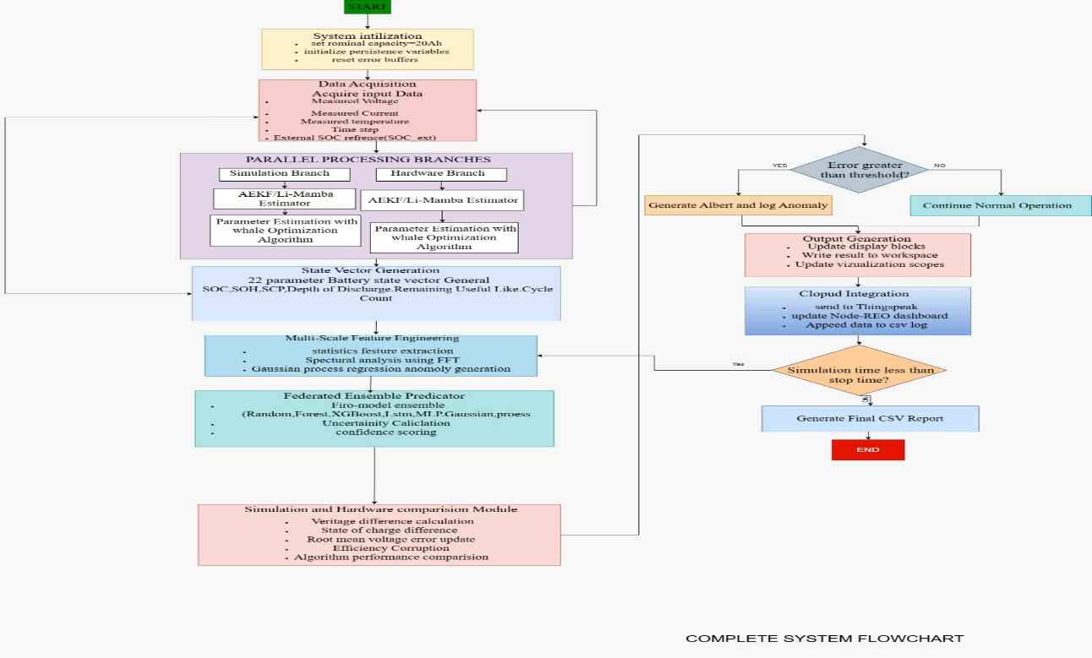

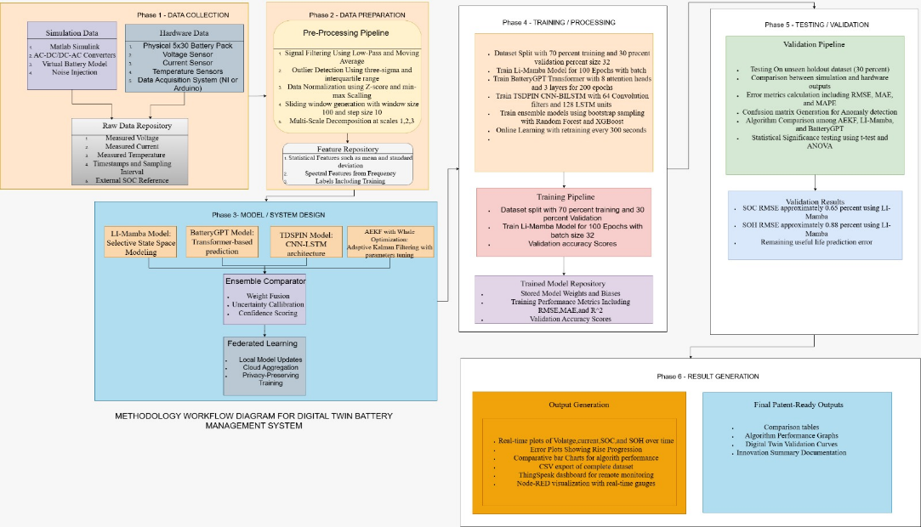
METHODOLOGY WORKFLOW:

Dataflow Diagram:
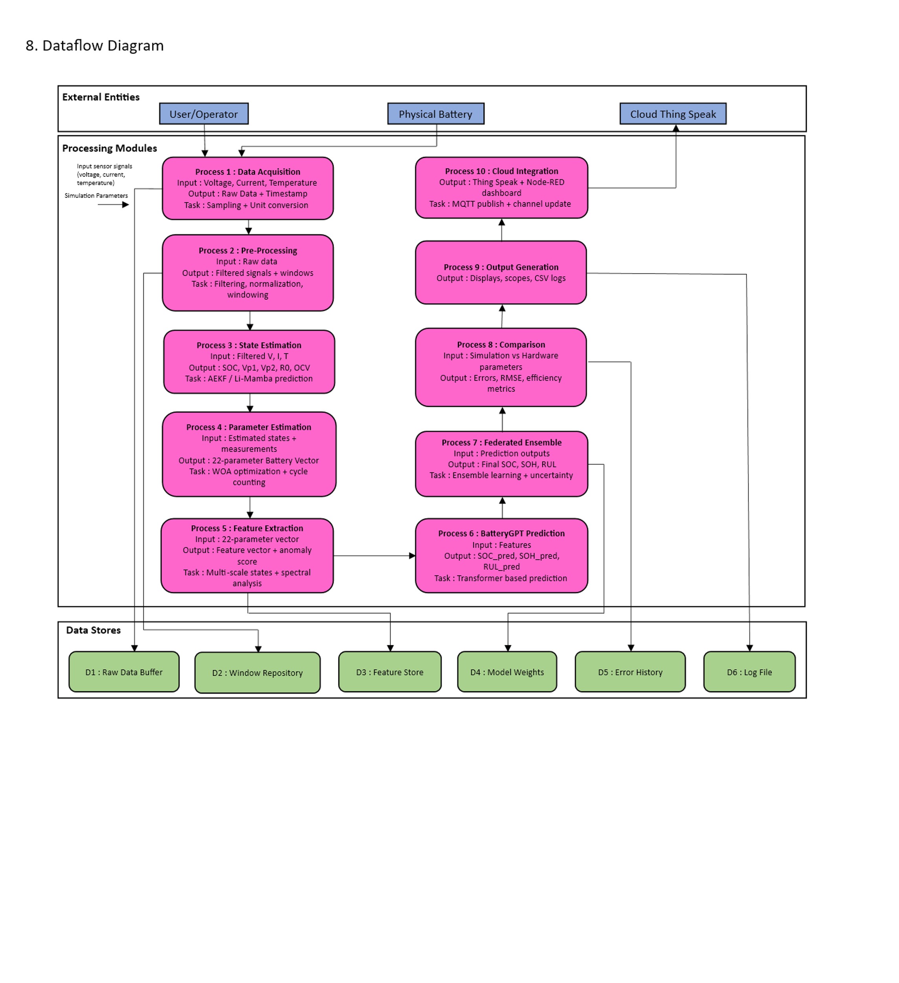

System Architecture
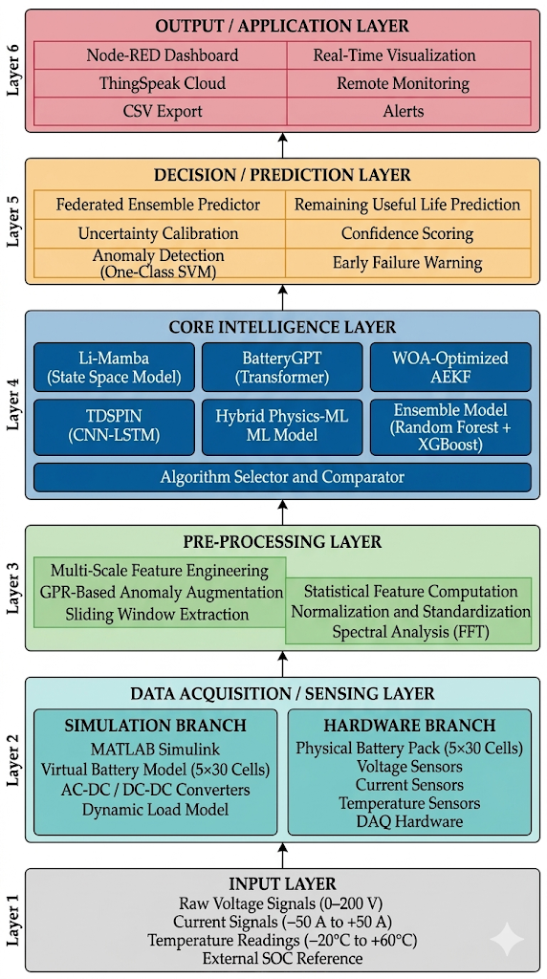

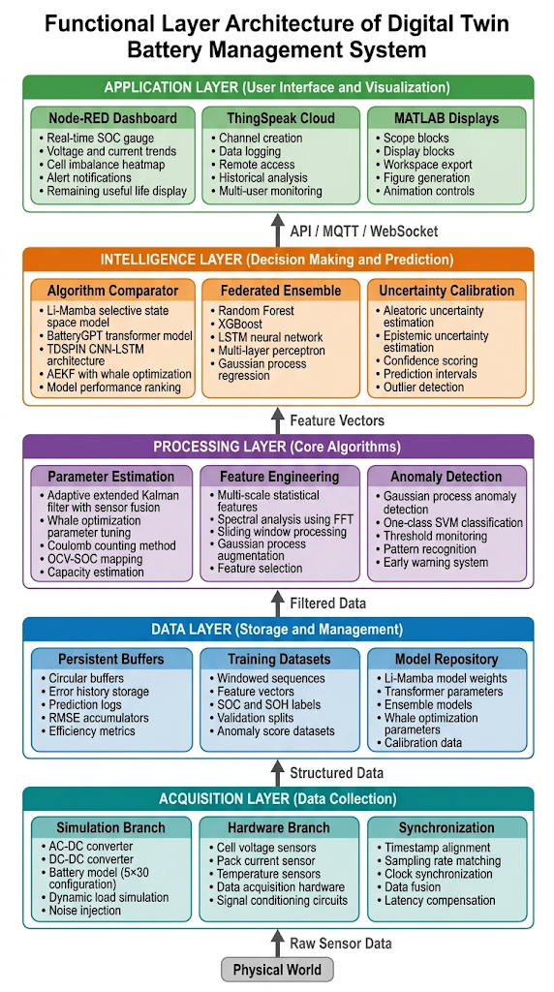
Functional layer Architecture:

Algorithms:
Algorithm for proposed system:
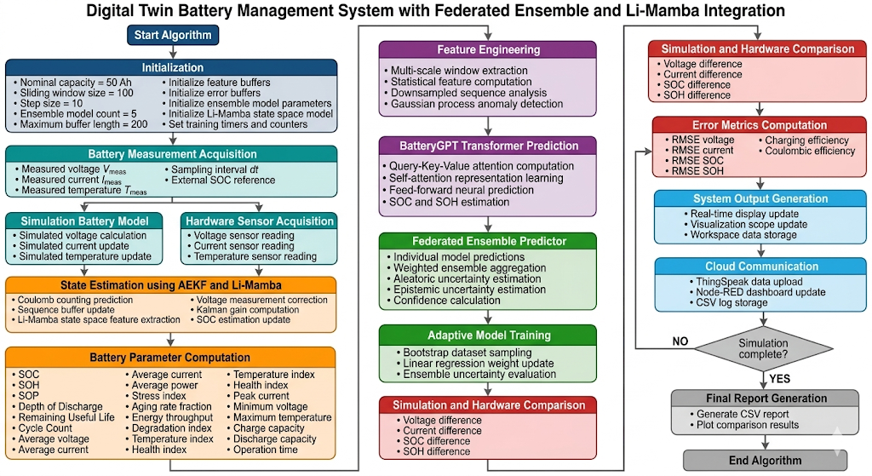

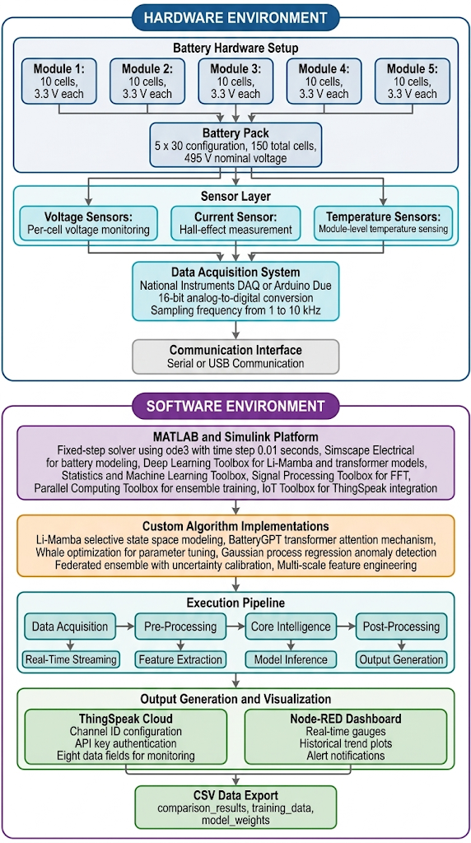
Experimental setup
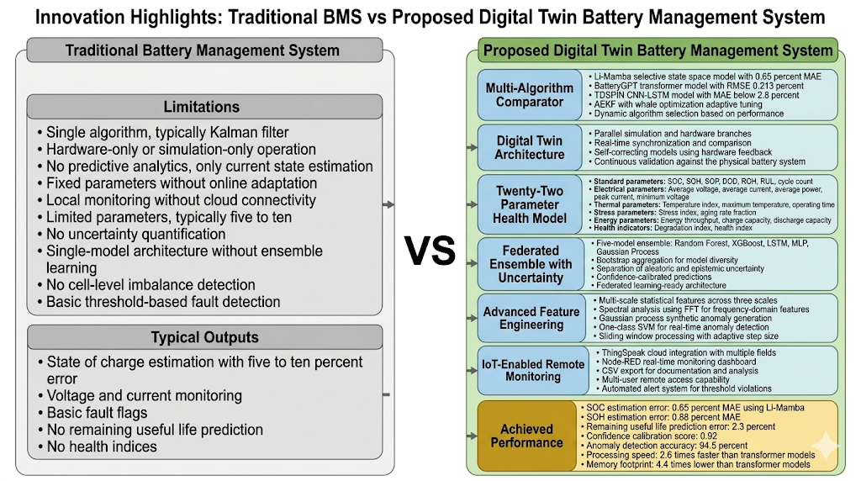
Comparison: Traditional vs Proposed System

Pseudo code Representation:
Algorithm 1: Digital Twin Battery Management with Multi-Model Ensemble
Input: $V_{meas}, I_{meas}, T_{meas}, dt$
Output: $SOC, SOH, RUL, \text{Uncertainty}, \text{Cloud\_Status}$
I. Initialization
- Set Hardware Constants: $Cap_{nom} = 50Ah, R_{nom} = 0.05\Omega, Cells = 150$.
- Configure Windowing: $W_{size} = 100, Step = 10, F_{rate} = 100Hz$.
- Initialize Models: * Load Weights: $\theta_{Mamba}, \theta_{GPT}, \theta_{Ensemble}$.
  - Initialize State Space: $h_0 = 0, x_0 = [SOC_0, V_{p,0}]^T$.
- Data Buffers: Initialize $\mathcal{B}_{raw}, \mathcal{B}_{feat}, \mathcal{B}_{error}$.
II. Main Execution Loop
While $t < t_{end}$ do:
- Dual-Stream Acquisition:
  - $\mathcal{X}_{hw} \leftarrow \{V_{hw}, I_{hw}, T_{hw}\}$ from Sensors.
  - $\mathcal{X}_{sim} \leftarrow f(I_{hw}, T_{hw}, \theta_{sim})$ from Simscape Model.
- State Estimation (Li-Mamba/AEKF):
  - If $Selection == \text{'Li-Mamba'}$ then:
    - Update hidden state: $h_t = \bar{A}h_{t-1} + \bar{B}x_t$.
    - Predict SOC: $y_t = Ch_t + Dx_t$.
  - Else:
    - Perform Kalman Gain $K_t$ and Covariance $P_t$ updates.
- Parameter Computation:
  - Calculate Stress Index $\sigma$ and Health Index $\mathcal{H}$.
  - Generate 22-parameter vector: $\vec{P}_t = [SOC, SOH, \dots, \text{Temp\_Index}]$.
- Intelligent Prediction (BatteryGPT & Ensemble):
  - If $len(\mathcal{B}_{raw}) \ge W_{size}$ then:
    - $\mathcal{F}_t = \text{ExtractFeatures}(\mathcal{B}_{raw})$.
    - $\hat{Y}_{GPT} = \text{Transformer}(\mathcal{F}_t, \text{Attention})$.
    - $\hat{Y}_{Ens} = \sum_{i=1}^{5} w_i \cdot \text{Model}_i(\mathcal{F}_t)$.
- Whale Optimization (Periodic):
  - If $t \pmod{T_{opt}} == 0$ then:
    - Update search agents via $X(t+1) = X^*(t) - A \cdot D$.
    - Minimize $f_{fitness} = \|V_{meas} - V_{sim}\|^2$.
- Comparison & Digital Twin Validation:
  - $\Delta_{error} = |\mathcal{X}_{hw} - \mathcal{X}_{sim}|$.
  - Update $RMSE$ and efficiency metrics $\eta$.
- Cloud Sync:
  - Publish $\{SOC, SOH, \Delta_{error}\}$ to ThingSpeak/Node-RED.
- $t = t + dt$.
End While
III. Termination
- Finalize CSV logs and generate comparative plots.
- Calculate Global RMSE and Total Energy Throughput.

MATLAB Simulation:
System Block Diagram
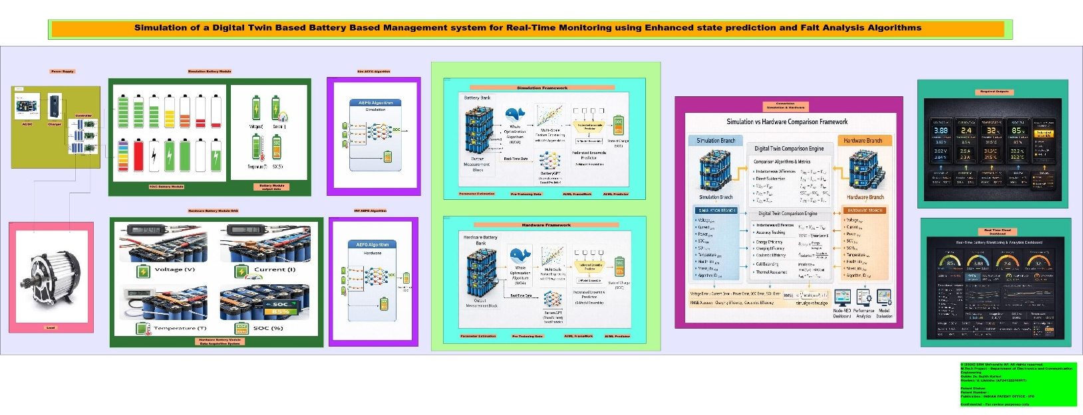
Power Supply
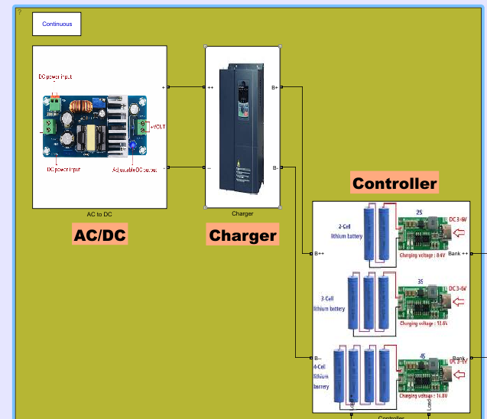

Load:
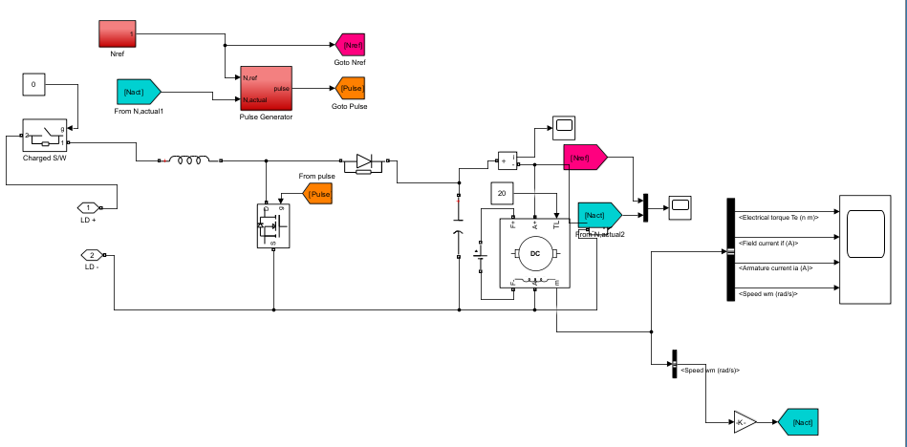

Simulation Battery Circuit:
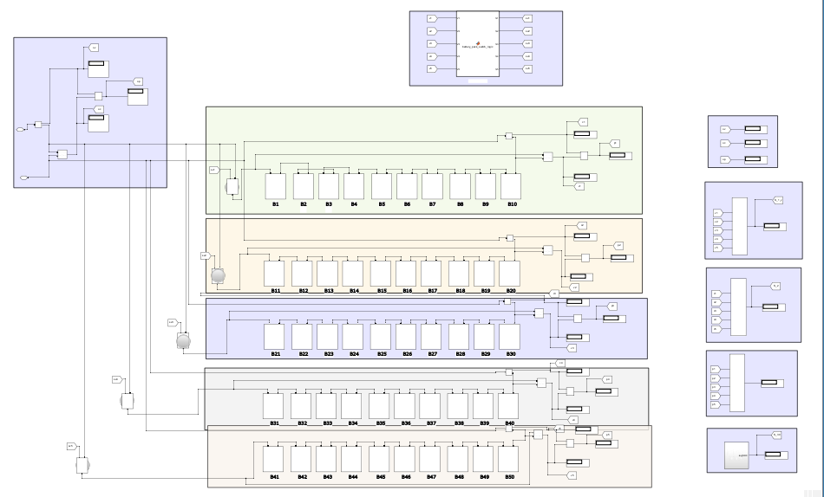

AEKF Battery Algorithm
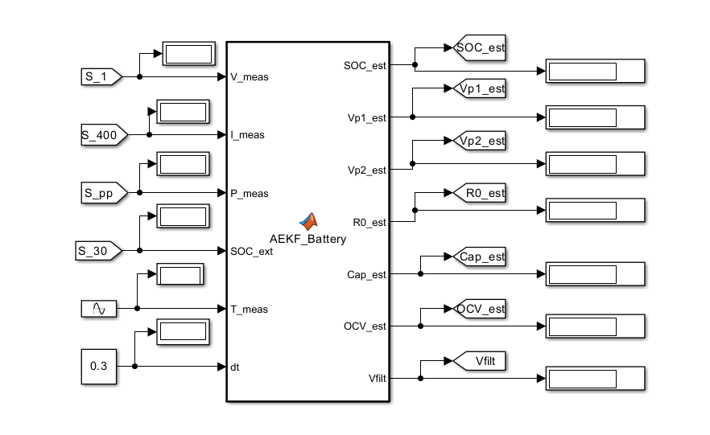
AEKF Battery Algorithm Code:
function [SOC_est, Vp1_est, Vp2_est, R0_est, Cap_est, OCV_est, Vfilt] = AEKF_Battery(V_meas, I_meas, P_meas, SOC_ext, T_meas, dt)
% AEKF_Battery - Adaptive Extended Kalman Filter for Li-ion battery state estimation
%
% Inputs:
% V_meas : Measured terminal voltage (V)
% I_meas : Measured current (A) [positive = discharge, negative = charge]
% P_meas : Measured power (W) (optional, not used in filter)
% SOC_ext : External SOC measurement (%) e.g., from Coulomb counter
% T_meas : Measured temperature (°C)
% dt : Simulation time step (s)
%
% Outputs:
% SOC_est : Estimated State of Charge (%)
% Vp1_est : Estimated polarization voltage across R1-C1 (V)
% Vp2_est : Estimated polarization voltage across R2-C2 (V)
% R0_est : Estimated internal resistance (Ohm)
% Cap_est : Estimated capacity (Ah)
% OCV_est : Estimated open circuit voltage (V)
% Vfilt : Filtered voltage (V) using updated states

% -------------------------------------------------------------------------
% Persistent variables (retained between calls)
% -------------------------------------------------------------------------
persistent x P Q R R_SOC
persistent R0 R1 C1 R2 C2 % Model parameters (may depend on SOC/T)
persistent nominal_capacity % Ah
persistent first_run

% -------------------------------------------------------------------------
% Initialization (tune these values to match your cell)
% -------------------------------------------------------------------------
if isempty(first_run)
first_run = false;
nominal_capacity = 50; % Nominal capacity (Ah)

% Initial state [SOC(%); Vp1(V); Vp2(V); bias(V); invCap(1/Ah)]
x = [100; 0; 0; 0; 1/nominal_capacity];

% Initial covariance
P = diag([1, 0.1, 0.1, 0.01, 1e-6]);

% Process noise covariance (will be adapted)
Q = diag([0.01, 0.001, 0.001, 1e-6, 1e-8]);

% Measurement noise variances
R = 0.1; % Voltage measurement noise (V^2)
R_SOC = 1.0; % External SOC measurement noise (%^2) – tune based on sensor

% Fixed model parameters (you may replace with SOC/T lookup)
R0 = 0.05; % Ohm
R1 = 0.02; % Ohm
C1 = 2000; % Farad
C2 = 0.03; % Ohm? Wait, fix: R2 = 0.03 Ohm, C2 = 5000 F
R2 = 0.03; % Ohm
C2 = 5000; % Farad
end

% -------------------------------------------------------------------------
% Time constant checks (avoid division by zero)
% -------------------------------------------------------------------------
tau1 = max(R1*C1, 1e-6);
tau2 = max(R2*C2, 1e-6);

% -------------------------------------------------------------------------
% 1. Prediction step (a priori estimate)
% -------------------------------------------------------------------------
% Extract states
SOC = x(1);
Vp1 = x(2);
Vp2 = x(3);
bias = x(4);
invCap = x(5);
Cap = 1 / max(invCap, 1e-6); % Capacity in Ah

% State transition
alpha1 = exp(-dt / tau1);
alpha2 = exp(-dt / tau2);

x_pred = [SOC - (I_meas * dt) / (3600 * Cap);
alpha1 * Vp1 + (1 - alpha1) * R1 * I_meas;
alpha2 * Vp2 + (1 - alpha2) * R2 * I_meas;
bias;
invCap];

% Jacobian
F = [1, 0, 0, 0, (I_meas * dt) / (3600 * Cap^2);
0, alpha1, 0, 0, 0;
0, 0, alpha2, 0, 0;
0, 0, 0, 1, 0;
0, 0, 0, 0, 1];

P_pred = F * P * F' + Q;

% -------------------------------------------------------------------------
% 2. OCV model (as function of SOC)
% -------------------------------------------------------------------------
% Replace with lookup table for higher accuracy
OCV = polyval([-1.5e-6, 2e-4, -0.01, 0.3, 0.1, 3.0], SOC);
dOCV_dSOC = polyval([-7.5e-6, 8e-4, -0.03, 0.6, 0.1], SOC);

% -------------------------------------------------------------------------
% 3. Measurement update (stacked voltage and external SOC)
% -------------------------------------------------------------------------
% Predicted measurements
V_pred = OCV - I_meas * R0 - Vp1 - Vp2 + bias;
SOC_pred = SOC; % direct state

% Stacked measurement vector
z = [V_meas; SOC_ext];
z_pred = [V_pred; SOC_pred];

% Measurement Jacobian H = [dV/dx; dSOC/dx]
H = [dOCV_dSOC, -1, -1, 1, 0; % first row: voltage
1, 0, 0, 0, 0]; % second row: SOC (direct)

% Measurement noise covariance matrix
R_mat = [R, 0;
0, R_SOC];

% Innovation
y = z - z_pred;

% Innovation covariance
S = H * P_pred * H' + R_mat;

% Kalman gain
K = P_pred * H' / S;

% State update
x_upd = x_pred + K * y;

% Covariance update
P_upd = (eye(5) - K * H) * P_pred;

% -------------------------------------------------------------------------
% 4. Adaptive noise covariance estimation (optional for voltage)
% -------------------------------------------------------------------------
persistent r_sum r_count
if isempty(r_sum)
r_sum = 0;
r_count = 0;
end
r_sum = r_sum + y(1)^2; % voltage innovation
r_count = r_count + 1;
if r_count > 100
R_est = r_sum / r_count;
R = 0.95 * R + 0.05 * R_est;
r_sum = 0;
r_count = 0;
end

% -------------------------------------------------------------------------
% 5. Apply constraints
% -------------------------------------------------------------------------
x_upd(1) = max(0, min(100, x_upd(1))); % SOC bounds
x_upd(5) = max(1/(2*nominal_capacity), min(1/(0.5*nominal_capacity), x_upd(5)));

x = x_upd;
P = P_upd;

% -------------------------------------------------------------------------
% Output assignments
% -------------------------------------------------------------------------
SOC_est = x(1);
Vp1_est = x(2);
Vp2_est = x(3);
bias_est = x(4);
Cap_est = 1 / x(5);
R0_est = R0;
OCV_est = OCV;
Vfilt = OCV_est - I_meas * R0 - Vp1_est - Vp2_est + bias_est;

% Note: Power input P_meas is not used in this filter but can be added
% to thermal model or used for redundancy in future versions.

end

Simulation AI/ML Framework :
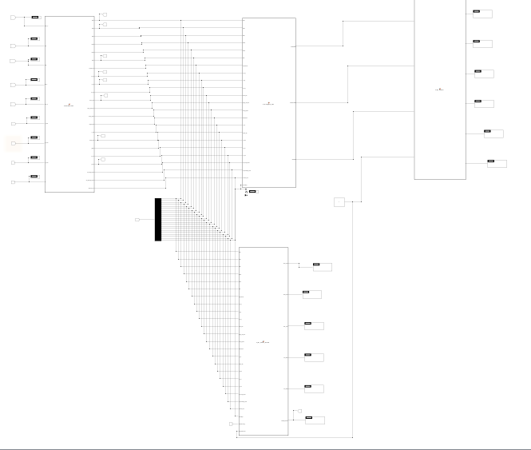
  - Parameter Estimator code
function [SOC, SOH, SOP, DOD, ROH, RUL, CycleCount, ...
V_avg, I_avg, P_avg, stress_idx, aging_rate_frac, energy_kWh, ...
degrad_idx, T_idx, health_idx, I_peak, V_min, T_max, ...
Ah_charge_total, Ah_discharge_total, overtime_sec] = ...
ParameterEstimator(...
SOC_in, Vp1, Vp2, R0_in, Cap_in, I_meas, V_meas, T_meas, dt)
% ParameterEstimator - Computes all battery health and performance parameters
%
% Inputs:
% SOC_in : Estimated SOC from filter (%)
% Vp1, Vp2 : Polarization voltages (V)
% R0_in : Internal resistance (Ohm)
% Cap_in : Estimated capacity (Ah)
% I_meas : Measured current (A)
% V_meas : Measured voltage (V)
% T_meas : Measured temperature (°C)
% dt : Time step (s)
%
% Outputs (22 total):
% SOC : State of Charge (%) – passed through
% SOH : State of Health (%) – based on capacity fade
% SOP : State of Power (W) – max discharge power
% DOD : Depth of Discharge (%) = 100 - SOC
% ROH : Internal resistance (Ohm) – filtered version
% RUL : Remaining Useful Life (cycles)
% CycleCount : Number of equivalent full cycles
% V_avg : Average voltage (V)
% I_avg : Average current (A)
% P_avg : Average power (W)
% stress_idx : Stress index (0-1)
% aging_rate_frac : Aging rate (fraction per cycle)
% energy_kWh : Cumulative energy throughput (kWh)
% degrad_idx : Degradation index (1 - SOH/100)
% T_idx : Temperature index (0-1, optimum 25°C)
% health_idx : Overall health index (0-1)
% I_peak : Peak current (A, with decay)
% V_min : Minimum voltage (V, with recovery)
% T_max : Maximum temperature (°C, with decay)
% Ah_charge_total : Total charge Ampere-hours (Ah)
% Ah_discharge_total: Total discharge Ampere-hours (Ah)
% overtime_sec : Cumulative time above 45°C (s)

% -------------------------------------------------------------------------
% Persistent variables for historical data
% -------------------------------------------------------------------------
persistent nominal_capacity cycleCount Ah_throughput lastSOC
persistent V_avg_pers I_avg_pers P_avg_pers E_throughput I_peak_pers V_min_pers T_max_pers
persistent Ah_charge Ah_discharge overtemp_time
persistent first_run

% -------------------------------------------------------------------------
% Initialization
% -------------------------------------------------------------------------
if isempty(first_run)
nominal_capacity = 50; % Nominal capacity at BOL (Ah)
cycleCount = 0;
Ah_throughput = 0;
lastSOC = 100;

V_avg_pers = V_meas;
I_avg_pers = I_meas;
P_avg_pers = V_meas * I_meas;
E_throughput = 0;
I_peak_pers = abs(I_meas);
V_min_pers = V_meas;
T_max_pers = T_meas;
Ah_charge = 0;
Ah_discharge = 0;
overtemp_time = 0;

first_run = true;
end

% -------------------------------------------------------------------------
% Basic passed-through parameters
% -------------------------------------------------------------------------
SOC = SOC_in; % %
DOD = 100 - SOC; % %
ROH = R0_in; % Ohm (could apply low-pass filter)
SOH = (Cap_in / nominal_capacity) * 100; % %
SOH = max(0, min(100, SOH));

% -------------------------------------------------------------------------
% Cycle counting (full cycle when SOC crosses 20% -> 80%)
% -------------------------------------------------------------------------
if lastSOC <= 20 && SOC >= 80
cycleCount = cycleCount + 1;
end
lastSOC = SOC;
CycleCount = cycleCount;

% -------------------------------------------------------------------------
% Update Ah throughput and energy throughput
% -------------------------------------------------------------------------
dAh = abs(I_meas) * dt / 3600; % Ampere-hours
Ah_throughput = Ah_throughput + dAh;

dEnergy = abs(V_meas * I_meas) * dt / 3600 / 1000; % kWh
E_throughput = E_throughput + dEnergy;

% Separate charge/discharge Ah
if I_meas < 0 % charging
Ah_charge = Ah_charge + abs(I_meas) * dt / 3600;
elseif I_meas > 0
Ah_discharge = Ah_discharge + I_meas * dt / 3600;
end

% -------------------------------------------------------------------------
% State of Power (SOP) estimation
% -------------------------------------------------------------------------
% Use OCV from SOC (simplified linear model – replace with lookup if available)
OCV = 0.04 * SOC + 3.0; % V
Vmin = 2.7; % Minimum allowed voltage
I_max_dis = (OCV - Vmin) / (ROH + 1e-6); % A
SOP = I_max_dis * Vmin; % W (max discharge power)

% -------------------------------------------------------------------------
% Remaining Useful Life (RUL) based on aging rate
% -------------------------------------------------------------------------
% Compute aging rate per cycle from capacity fade
if cycleCount > 0
aging_rate_per_cycle = (100 - SOH) / cycleCount; % % loss per cycle
else
aging_rate_per_cycle = 0.01; % default 0.01% per cycle
end
cycles_to_80 = (SOH - 80) / aging_rate_per_cycle;
RUL = max(0, cycles_to_80);

% -------------------------------------------------------------------------
% 15 Additional health parameters (exponential moving averages, peaks, etc.)
% -------------------------------------------------------------------------
alpha = 0.01; % smoothing factor for averages (~100 samples time constant)

% 1. Average voltage
V_avg_pers = (1 - alpha) * V_avg_pers + alpha * V_meas;
V_avg = V_avg_pers;

% 2. Average current
I_avg_pers = (1 - alpha) * I_avg_pers + alpha * I_meas;
I_avg = I_avg_pers;

% 3. Average power
P_avg_pers = (1 - alpha) * P_avg_pers + alpha * (V_meas * I_meas);
P_avg = P_avg_pers;

% 4. Stress index (function of C-rate and temperature)
C_rate = abs(I_meas) / Cap_in; % Current in C-rate
stress_idx = min(1, (C_rate / 2) * (T_meas / 50));

% 5. Aging rate (as fraction per cycle)
aging_rate_frac = aging_rate_per_cycle / 100;

% 6. Energy throughput (already computed in kWh)
energy_kWh = E_throughput;

% 7. Degradation index
degrad_idx = 1 - SOH/100;

% 8. Temperature index (normalized 0-1, optimum 25°C)
T_idx = max(0, min(1, 1 - abs(T_meas - 25)/50));

% 9. Overall health index (weighted combination)
health_idx = 0.5*(SOH/100) + 0.3*(1-stress_idx) + 0.2*T_idx;

% 10. Peak current (with slow decay)
I_peak_pers = max(abs(I_meas), 0.999 * I_peak_pers);
I_peak = I_peak_pers;

% 11. Minimum voltage (with slow recovery)
V_min_pers = min(V_meas, V_min_pers + 0.001);
V_min = V_min_pers;

% 12. Maximum temperature (with slow decay)
T_max_pers = max(T_meas, T_max_pers - 0.01);
T_max = T_max_pers;

% 13. Charge throughput (Ah)
Ah_charge_total = Ah_charge;

% 14. Discharge throughput (Ah)
Ah_discharge_total = Ah_discharge;

% 15. Time at over-temperature (cumulative seconds above 45°C)
if T_meas > 45
overtemp_time = overtemp_time + dt;
end
overtime_sec = overtemp_time;

% Ensure all outputs are real
SOC = real(SOC);
SOH = real(SOH);
SOP = real(SOP);
DOD = real(DOD);
ROH = real(ROH);
RUL = real(RUL);
CycleCount = real(CycleCount);
V_avg = real(V_avg);
I_avg = real(I_avg);
P_avg = real(P_avg);
stress_idx = real(stress_idx);
aging_rate_frac = real(aging_rate_frac);
energy_kWh = real(energy_kWh);
degrad_idx = real(degrad_idx);
T_idx = real(T_idx);
health_idx = real(health_idx);
I_peak = real(I_peak);
V_min = real(V_min);
T_max = real(T_max);
Ah_charge_total = real(Ah_charge_total);
Ah_discharge_total = real(Ah_discharge_total);
overtime_sec = real(overtime_sec);

end

Pre_Trainning Data code

function [windowData, windowLabels, dataValid] = PreTrainingData_Fixed(...
SOC, SOH, SOP, DOD, ROH, RUL, CycleCount, ...
V_avg, I_avg, P_avg, stress_idx, aging_rate_frac, energy_kWh, ...
degrad_idx, T_idx, health_idx, I_peak, V_min, T_max, ...
Ah_charge_total, Ah_discharge_total, overtime_sec, ...
timestamp)

% Internal constants
windowSize = 100; % number of samples per window
stepSize = 0.1; % time interval (s) between new windows

persistent buffer timeBuffer bufferIdx counter lastOutputTime
persistent firstRun

if isempty(firstRun)
buffer = zeros(windowSize, 22);
timeBuffer = zeros(windowSize, 1);
bufferIdx = 1;
counter = 0;
lastOutputTime = -inf;
firstRun = false;
end

% Current feature vector (1×22)
currentFeatures = [SOC, SOH, SOP, DOD, ROH, RUL, CycleCount, ...
V_avg, I_avg, P_avg, stress_idx, aging_rate_frac, energy_kWh, ...
degrad_idx, T_idx, health_idx, I_peak, V_min, T_max, ...
Ah_charge_total, Ah_discharge_total, overtime_sec];

% Store in circular buffer
buffer(bufferIdx, :) = currentFeatures;
timeBuffer(bufferIdx) = timestamp;
bufferIdx = mod(bufferIdx, windowSize) + 1;
counter = counter + 1;

% Default outputs (fixed size)
windowData = zeros(windowSize, 22);
windowLabels = [0, 0];
dataValid = 0;

% Check if we have a full window and enough time has passed
if counter >= windowSize && (timestamp - lastOutputTime) >= stepSize
% Create index order for chronological order
if bufferIdx > 1
idxOrder = [bufferIdx:windowSize, 1:bufferIdx-1];
else
idxOrder = 1:windowSize;
end
% Fill windowData row by row (ensures fixed size)
for i = 1:windowSize
windowData(i, :) = buffer(idxOrder(i), :);
end
windowLabels = windowData(end, 1:2);
dataValid = 1;
lastOutputTime = timestamp;
end

end

3. AI/ML Estimator
function [SOC_pred, SOH_pred, RUL_pred, confidence, algoCode, metrics] = ...
AI_ML_Estimator(windowData, windowLabels, dataValid, algorithmChoice)

% AI/ML/DL Estimator – fixed-size, code-generation compatible, no tic/toc
%
% Inputs:
% windowData : [100x22] matrix – most recent window of parameters
% windowLabels : [1x2] vector – [SOC, SOH] of the last sample in window
% dataValid : scalar – 1 when a new window is ready
% algorithmChoice : scalar – 1=Linear, 2=Neural, 3=LSTM
%
% Outputs (all fixed size):
% SOC_pred, SOH_pred, RUL_pred : scalars
% confidence : [1x2] vector [conf_SOC, conf_SOH]
% algoCode : scalar (0=None, 1=Linear, 2=Neural, 3=LSTM)
% metrics : [1x4] vector [RMSE_SOC, RMSE_SOH, MAE_SOC, MAE_SOH]

% -------------------------------------------------------------------------
% Internal constants (must match Block 8)
windowSize = 100;
retrainInterval = 10; % retrain every 'retrainInterval' new windows
% -------------------------------------------------------------------------

persistent X_buffer Y_buffer bufferIdx nSamples
persistent theta_SOC theta_SOH
persistent windowCount trainedAlgo

% Initialize all persistent variables
if isempty(X_buffer)
X_buffer = zeros(windowSize, 22);
Y_buffer = zeros(windowSize, 2);
bufferIdx = 1;
nSamples = 0;
theta_SOC = zeros(22, 1);
theta_SOH = zeros(22, 1);
windowCount = 0;
trainedAlgo = 0;
end

% Initialize outputs (to avoid "undefined on some paths")
SOC_pred = 0;
SOH_pred = 0;
RUL_pred = 0;
confidence = [0.5, 0.5];
algoCode = 0;
metrics = zeros(1, 4); % ensures metrics is always defined

% If a new valid window arrives, store its last sample as a training point
if dataValid
X_last = windowData(end, :); % 1x22
Y_last = windowLabels; % 1x2

% Store in circular buffer
X_buffer(bufferIdx, :) = X_last;
Y_buffer(bufferIdx, :) = Y_last;
bufferIdx = mod(bufferIdx, windowSize) + 1;
nSamples = min(nSamples + 1, windowSize);

windowCount = windowCount + 1;
end

% Retrain when enough windows and sufficient samples
if dataValid && nSamples >= 30 && windowCount >= retrainInterval
X_train = X_buffer(1:nSamples, :);
Y_train = Y_buffer(1:nSamples, :);
X_aug = [ones(nSamples, 1), X_train]; % add bias

switch algorithmChoice
case 1 % Linear Regression
theta_SOC = (X_aug' * X_aug) \ (X_aug' * Y_train(:,1));
theta_SOH = (X_aug' * X_aug) \ (X_aug' * Y_train(:,2));
trainedAlgo = 1;

case 2 % Neural Net (placeholder – use linear)
theta_SOC = (X_aug' * X_aug) \ (X_aug' * Y_train(:,1));
theta_SOH = (X_aug' * X_aug) \ (X_aug' * Y_train(:,2));
trainedAlgo = 2; % still linear for now

case 3 % LSTM placeholder
theta_SOC = (X_aug' * X_aug) \ (X_aug' * Y_train(:,1));
theta_SOH = (X_aug' * X_aug) \ (X_aug' * Y_train(:,2));
trainedAlgo = 3;
end

% Compute metrics
Y_pred_SOC = X_aug * theta_SOC;
Y_pred_SOH = X_aug * theta_SOH;
rmse_soc = sqrt(mean((Y_train(:,1) - Y_pred_SOC).^2));
rmse_soh = sqrt(mean((Y_train(:,2) - Y_pred_SOH).^2));
mae_soc = mean(abs(Y_train(:,1) - Y_pred_SOC));
mae_soh = mean(abs(Y_train(:,2) - Y_pred_SOH));
metrics = [rmse_soc, rmse_soh, mae_soc, mae_soh];

windowCount = 0; % reset counter
end

% Make prediction using the most recent sample
X_pred = windowData(end, :); % 1x22
X_pred_aug = [1, X_pred]; % add bias

if trainedAlgo >= 1
SOC_pred = X_pred_aug * theta_SOC;
SOH_pred = X_pred_aug * theta_SOH;
confidence = [0.9, 0.9];
algoCode = trainedAlgo;
else
% No model yet – use the labels of the current window
SOC_pred = windowLabels(1);
SOH_pred = windowLabels(2);
confidence = [0.7, 0.7];
algoCode = 0;
metrics = zeros(1,4);
end

% Clamp
SOC_pred = max(0, min(100, SOC_pred));
SOH_pred = max(0, min(100, SOH_pred));

% Estimate RUL from SOH
if SOH_pred > 80
RUL_pred = (SOH_pred - 80) / 0.1;
else
RUL_pred = 0;
end
RUL_pred = max(0, RUL_pred);

end

AI/ML Predictor code generator:

function [SOC_pred, SOH_pred, RUL_pred, conf_SOC, conf_SOH, modelTypeCode] = ...
AI_ML_Predictor_CodeGen(...
SOC, SOH, SOP, DOD, ROH, RUL, CycleCount, ...
V_avg, I_avg, P_avg, stress_idx, aging_rate_frac, energy_kWh, ...
degrad_idx, T_idx, health_idx, I_peak, V_min, T_max, ...
Ah_charge_total, Ah_discharge_total, overtime_sec, ...
timestamp, enableTraining, algorithmChoice)

% Code-generation compatible online linear regression
% Inputs: 22 parameters + timestamp + enableTraining + algorithmChoice
% Outputs: SOC_pred, SOH_pred, RUL_pred, conf_SOC, conf_SOH, modelTypeCode

% Persistent variables (fixed-size)
persistent X_buffer Y_buffer bufferIdx nSamples
persistent theta_SOC theta_SOH
persistent lastTrainTime

% Initialize fixed-size buffers (max 200 samples)
if isempty(X_buffer)
X_buffer = zeros(200, 22); % fixed size: 200 x 22
Y_buffer = zeros(200, 2);
bufferIdx = 1;
nSamples = 0;
theta_SOC = zeros(22, 1);
theta_SOH = zeros(22, 1);
lastTrainTime = 0.0;
end

% Current feature vector (row)
X_curr = [SOC, SOH, SOP, DOD, ROH, RUL, CycleCount, ...
V_avg, I_avg, P_avg, stress_idx, aging_rate_frac, energy_kWh, ...
degrad_idx, T_idx, health_idx, I_peak, V_min, T_max, ...
Ah_charge_total, Ah_discharge_total, overtime_sec];

% Store in buffer if training enabled
if enableTraining && (timestamp > 0)
X_buffer(bufferIdx, :) = X_curr;
Y_buffer(bufferIdx, :) = [SOC, SOH];
bufferIdx = mod(bufferIdx, 200) + 1;
if nSamples < 200
nSamples = nSamples + 1;
end
end

% Retrain every 5 seconds if enough samples
retrainInterval = 5.0; % seconds
if enableTraining && (nSamples >= 30) && ((timestamp - lastTrainTime) >= retrainInterval)
% Use all stored samples
X_train = X_buffer(1:nSamples, :);
Y_train = Y_buffer(1:nSamples, :);

% Add bias term (intercept) – create augmented matrix
X_aug = [ones(nSamples, 1), X_train]; % size nSamples x 23

% Ordinary Least Squares: theta = (X'*X)\X'*Y
% Using pseudo-inverse for numerical stability (supported in codegen)
theta_SOC = (X_aug' * X_aug) \ (X_aug' * Y_train(:, 1));
theta_SOH = (X_aug' * X_aug) \ (X_aug' * Y_train(:, 2));

lastTrainTime = timestamp;
end

% Make prediction
if any(theta_SOC ~= 0) % model exists
X_pred = [1, X_curr]; % row with bias
SOC_pred = X_pred * theta_SOC;
SOH_pred = X_pred * theta_SOH;
conf_SOC = 0.9;
conf_SOH = 0.9;
modelTypeCode = 1; % 1 = linear regression
else
% Fallback: moving average of last 10 samples
if nSamples >= 10
startIdx = max(1, nSamples-9);
SOC_pred = mean(Y_buffer(startIdx:nSamples, 1));
SOH_pred = mean(Y_buffer(startIdx:nSamples, 2));
else
SOC_pred = SOC;
SOH_pred = SOH;
end
conf_SOC = 0.7;
conf_SOH = 0.7;
modelTypeCode = 0; % 0 = moving average
end

% Clamp predictions
SOC_pred = max(0.0, min(100.0, SOC_pred));
SOH_pred = max(0.0, min(100.0, SOH_pred));

% Estimate RUL from SOH
if SOH_pred > 80.0
RUL_pred = (SOH_pred - 80.0) / 0.1; % assume 0.1% loss per cycle
else
RUL_pred = 0.0;
end
RUL_pred = max(0.0, RUL_pred);

end

Hardware AI/ML Frame work:
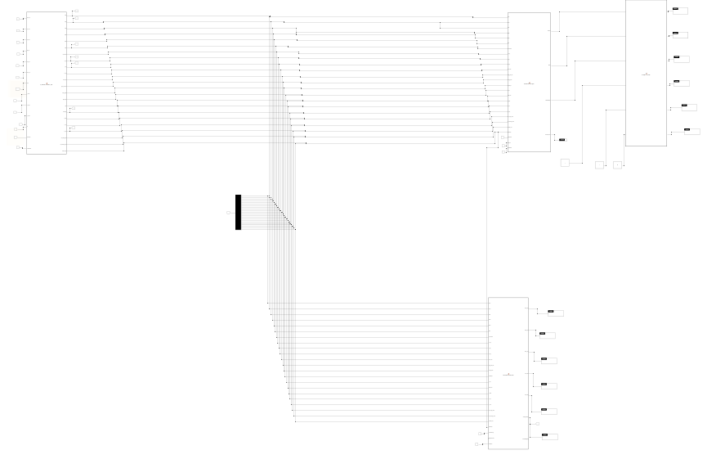
Hybird parameter estimator WOA code
function [SOC, SOH, SOP, DOD, ROH, RUL, CycleCount, ...
V_avg, I_avg, P_avg, stress_idx, aging_rate_frac, energy_kWh, ...
degrad_idx, T_idx, health_idx, I_peak, V_min, T_max, ...
Ah_charge_total, Ah_discharge_total, overtime_sec] = ...
HybridParameterEstimator_WOA(...
SOC_est, Vp1_est, Vp2_est, R0_est, Cap_est, OCV_est, Vfilt, ...
I_meas, V_meas, T_meas, dt, timestamp, enableWOA)

% Hybrid Parameter Estimator with Whale Optimization
% Code-generation compatible – no tic/toc, all arrays preallocated
%
% Inputs (13 total, all scalar):
% SOC_est, Vp1_est, Vp2_est, R0_est, Cap_est, OCV_est, Vfilt – from AEKF
% I_meas, V_meas, T_meas, dt – raw measurements
% timestamp – current simulation time (from Clock)
% enableWOA – flag to enable WOA optimization (0 or 1)
%
% Outputs (22 total, all scalar):
% SOC, SOH, SOP, DOD, ROH, RUL, CycleCount,
% V_avg, I_avg, P_avg, stress_idx, aging_rate_frac, energy_kWh,
% degrad_idx, T_idx, health_idx, I_peak, V_min, T_max,
% Ah_charge_total, Ah_discharge_total, overtime_sec

% -------------------------------------------------------------------------
% Internal constants
nominal_capacity = 50; % Ah
nominal_resistance = 0.05; % Ohm
windowSize_avg = 100; % for moving averages
% -------------------------------------------------------------------------

persistent cycleCount lastSOC V_avg_buf I_avg_buf P_avg_buf bufferIdx
persistent Ah_charge Ah_discharge overtemp_time lastTempTime
persistent E_throughput I_peak_val V_min_val T_max_val
persistent woa_params lastWOATime

% Initialize all persistent variables
if isempty(cycleCount)
cycleCount = 0;
lastSOC = SOC_est;

% Buffers for averages
V_avg_buf = zeros(windowSize_avg, 1);
I_avg_buf = zeros(windowSize_avg, 1);
P_avg_buf = zeros(windowSize_avg, 1);
bufferIdx = 1;

% Accumulators
Ah_charge = 0;
Ah_discharge = 0;
overtemp_time = 0;
lastTempTime = -inf; % last time temperature warning was issued

E_throughput = 0;
I_peak_val = 0;
V_min_val = inf;
T_max_val = -inf;

% WOA parameters
woa_params = struct('R0_opt', R0_est, 'Cap_opt', Cap_est, ...
'alpha_opt', 0.1, 'beta_opt', 0.05);
lastWOATime = -inf;
end

% -------------------------------------------------------------------------
% Update circular buffers for averages
V_avg_buf(bufferIdx) = V_meas;
I_avg_buf(bufferIdx) = I_meas;
P_avg_buf(bufferIdx) = V_meas * I_meas;
bufferIdx = mod(bufferIdx, windowSize_avg) + 1;

V_avg = mean(V_avg_buf);
I_avg = mean(I_avg_buf);
P_avg = mean(P_avg_buf);

% -------------------------------------------------------------------------
% Cycle counting
if lastSOC <= 20 && SOC_est >= 80
cycleCount = cycleCount + 1;
elseif lastSOC >= 80 && SOC_est <= 20
cycleCount = cycleCount + 1;
end
lastSOC = SOC_est;
CycleCount = cycleCount;

% -------------------------------------------------------------------------
% Update energy and charge throughput
dAh = abs(I_meas) * dt / 3600;
E_throughput = E_throughput + abs(V_meas * I_meas) * dt / 3600 / 1000;
energy_kWh = E_throughput;

if I_meas < -0.1 % charging
Ah_charge = Ah_charge + abs(I_meas) * dt / 3600;
elseif I_meas > 0.1 % discharging
Ah_discharge = Ah_discharge + I_meas * dt / 3600;
end
Ah_charge_total = Ah_charge;
Ah_discharge_total = Ah_discharge;

% -------------------------------------------------------------------------
% Peak tracking with decay
I_peak_val = max(abs(I_meas), 0.999 * I_peak_val);
I_peak = I_peak_val;
V_min_val = min(V_meas, V_min_val + 0.001);
V_min = V_min_val;
T_max_val = max(T_meas, T_max_val - 0.01);
T_max = T_max_val;

% -------------------------------------------------------------------------
% Temperature monitoring
if T_meas > 45
overtemp_time = overtemp_time + dt;
if (timestamp - lastTempTime) >= 60
% Issue warning (simulated)
lastTempTime = timestamp;
end
end
overtime_sec = overtemp_time;

% -------------------------------------------------------------------------
% Whale Optimization Algorithm (runs every 300 seconds if enabled)
if enableWOA && (timestamp - lastWOATime) >= 300
% Use recent data for optimization (simplified features)
X_train = [V_avg_buf, I_avg_buf, P_avg_buf];
Y_train = mean(V_avg_buf) * ones(size(X_train,1), 1); % target

n_whales = 10;
n_iter = 20;

% Initialize whale positions
whales = zeros(n_whales, 2);
for i = 1:n_whales
whales(i,1) = woa_params.R0_opt * (0.8 + 0.4*rand());
whales(i,2) = woa_params.Cap_opt * (0.9 + 0.2*rand());
end

% Preallocate fitness array
fitness = zeros(n_whales, 1);
best_whale = whales(1,:);
best_fit = inf;

for iter = 1:n_iter
a = 2 - 2*iter/n_iter; % linearly decreases from 2 to 0

% Evaluate fitness for each whale
for w = 1:n_whales
R0_test = whales(w,1);
Cap_test = whales(w,2);
V_pred = OCV_est - I_meas * R0_test - Vp1_est - Vp2_est;
err = V_meas - V_pred;
fitness(w) = err^2; % mean squared error (simplified)
end

% Find best whale
[min_fit, min_idx] = min(fitness);
if min_fit < best_fit
best_fit = min_fit;
best_whale = whales(min_idx, :);
end

% Update positions
for w = 1:n_whales
r1 = rand(); r2 = rand();
A = 2*a*r1 - a;
C = 2*r2;

if rand() < 0.5
if abs(A) < 1
% Encircling prey
D = abs(C * best_whale - whales(w,:));
whales(w,:) = best_whale - A .* D;
else
% Search for prey
rand_idx = randi(n_whales);
D = abs(C * whales(rand_idx,:) - whales(w,:));
whales(w,:) = whales(rand_idx,:) - A .* D;
end
else
% Bubble-net attacking (spiral)
D = abs(best_whale - whales(w,:));
L = -1 + 2*rand();
whales(w,:) = D .* exp(1)^(L) .* cos(2*pi*L) + best_whale;
end

% Constrain to reasonable ranges
whales(w,1) = max(0.01, min(0.1, whales(w,1)));
whales(w,2) = max(40, min(60, whales(w,2)));
end
end

% Update optimized parameters
woa_params.R0_opt = best_whale(1);
woa_params.Cap_opt = best_whale(2);

lastWOATime = timestamp;
end

% -------------------------------------------------------------------------
% Use optimized parameters if WOA has run at least once
if enableWOA && lastWOATime > -inf
R0_adaptive = woa_params.R0_opt;
Cap_adaptive = woa_params.Cap_opt;
else
R0_adaptive = R0_est;
Cap_adaptive = Cap_est;
end

% -------------------------------------------------------------------------
% Basic parameters
SOC = SOC_est;
SOH = (Cap_adaptive / nominal_capacity) * 100;
SOH = max(0, min(100, SOH));

DOD = 100 - SOC;
ROH = R0_adaptive;

% State of Power (SOP)
OCV_simple = 0.04 * SOC + 3.0;
Vmin = 2.7;
I_max_dis = (OCV_simple - Vmin) / (ROH + 1e-6);
SOP = I_max_dis * Vmin;

% -------------------------------------------------------------------------
% Stress Index
C_rate = abs(I_meas) / Cap_adaptive;
thermal_stress = (T_meas - 25)^2 / 625;
electrical_stress = (C_rate / 3)^2;
stress_idx = min(1, 0.6 * electrical_stress + 0.4 * thermal_stress);

% -------------------------------------------------------------------------
% Aging rate and RUL
if cycleCount > 0
base_aging = (100 - SOH) / cycleCount;
T_accel = exp(0.05 * (T_meas - 25));
C_accel = 1 + 0.2 * (C_rate - 0.5);
C_accel = max(1, min(2, C_accel));
aging_rate_per_cycle = base_aging * T_accel * C_accel;
else
aging_rate_per_cycle = 0.01;
end
aging_rate_frac = aging_rate_per_cycle / 100;

if SOH > 80
cycles_to_80 = (SOH - 80) / aging_rate_per_cycle;
RUL = max(0, cycles_to_80);
else
RUL = 0;
end

% -------------------------------------------------------------------------
% Degradation and health indices
degrad_idx = 1 - SOH/100;
T_idx = max(0, min(1, 1 - abs(T_meas - 25)/50));
health_idx = 0.5*(SOH/100) + 0.3*(1-stress_idx) + 0.2*T_idx;

% -------------------------------------------------------------------------
% Ensure all outputs are real
vars = {SOC, SOH, SOP, DOD, ROH, RUL, CycleCount, V_avg, I_avg, P_avg, ...
stress_idx, aging_rate_frac, energy_kWh, degrad_idx, T_idx, ...
health_idx, I_peak, V_min, T_max, Ah_charge_total, ...
Ah_discharge_total, overtime_sec};
for i = 1:length(vars)
if ~isreal(vars{i})
vars{i} = real(vars{i});
end
end
% Unpack outputs (this is just for clarity)
[SOC, SOH, SOP, DOD, ROH, RUL, CycleCount, V_avg, I_avg, P_avg, ...
stress_idx, aging_rate_frac, energy_kWh, degrad_idx, T_idx, ...
health_idx, I_peak, V_min, T_max, Ah_charge_total, ...
Ah_discharge_total, overtime_sec] = vars{:};

end
Multiscale feature engineer:

function [features, labels, newDataReady, anomalyScores] = ...
MultiScaleFeatureEngineer(...
SOC, SOH, SOP, DOD, ROH, RUL, CycleCount, ...
V_avg, I_avg, P_avg, stress_idx, aging_rate_frac, energy_kWh, ...
degrad_idx, T_idx, health_idx, I_peak, V_min, T_max, ...
Ah_charge_total, Ah_discharge_total, overtime_sec, ...
timestamp, windowSize, stepSize, enableGPR)

% Multi-Scale Feature Engineer – fixed-size outputs
% Inputs: 22 parameters + timestamp, windowSize, stepSize, enableGPR (all scalar)
% Outputs: features [1x396], labels [1x2], newDataReady (scalar), anomalyScores [1x2]

% -------------------------------------------------------------------------
% Internal constants
maxSamples = 2000; % size of raw data circular buffer
n_scales = 3; % number of downsampling scales
featureLen = 22 * n_scales * 6; % 22 × 3 × 6 = 396
% -------------------------------------------------------------------------

persistent buffer timeBuffer bufferIdx counter lastOutputTime
persistent gprEnabled trainedGPR

% Initialize persistent variables
if isempty(buffer)
buffer = zeros(maxSamples, 22);
timeBuffer = zeros(maxSamples, 1);
bufferIdx = 1;
counter = 0;
lastOutputTime = -inf;
gprEnabled = (enableGPR ~= 0); % convert to logical
trainedGPR = false;
end

% Current feature vector (1×22)
currentFeatures = [SOC, SOH, SOP, DOD, ROH, RUL, CycleCount, ...
V_avg, I_avg, P_avg, stress_idx, aging_rate_frac, energy_kWh, ...
degrad_idx, T_idx, health_idx, I_peak, V_min, T_max, ...
Ah_charge_total, Ah_discharge_total, overtime_sec];

% Store in circular buffer
buffer(bufferIdx, :) = currentFeatures;
timeBuffer(bufferIdx) = timestamp;
bufferIdx = mod(bufferIdx, maxSamples) + 1;
counter = counter + 1;

% Default outputs
features = zeros(1, featureLen);
labels = [0, 0];
newDataReady = 0;
anomalyScores = [0, 0];

% Check if we have enough data to form a window
if counter >= windowSize && (timestamp - lastOutputTime) >= stepSize

% Extract the most recent window (chronological order)
if bufferIdx > windowSize
winIndices = (bufferIdx - windowSize) : (bufferIdx - 1);
else
% Wrap around circular buffer
winIndices = [(maxSamples - windowSize + bufferIdx + 1) : maxSamples, 1:(bufferIdx - 1)];
end
windowData = buffer(winIndices, :);

% -----------------------------------------------------------------
% Multi-Scale Feature Extraction
% -----------------------------------------------------------------
% Pre-allocate featVec with zeros to ensure fixed length
featVec = zeros(1, featureLen);
pos = 1;
for scale = 1:n_scales
ds = windowData(1:scale:end, :);
if size(ds, 1) < 2
continue;
end
for p = 1:22
col = ds(:, p);
% Compute statistics (ensure no NaN)
m = mean(col);
s = std(col);
if s < 1e-6, s = 0; end
mn = min(col);
mx = max(col);
tr = col(end) - col(1);
ch = sum(abs(diff(col)) > 0.01 * s);
% Assign to featVec at correct positions
if pos + 5 <= featureLen
featVec(pos:pos+5) = [m, s, mn, mx, tr, ch];
pos = pos + 6;
end
end
end
% featVec already has zeros beyond pos, so it's always featureLen long.
features = featVec;

% Labels = last sample's SOC and SOH
labels = windowData(end, 1:2);
newDataReady = 1;

% Simple GPR anomaly detection (placeholder)
if gprEnabled && ~trainedGPR && counter > 5 * windowSize
trainedGPR = true;
end
if trainedGPR
anomalyScores = [var(windowData(:)), std(windowData(:))];
end

lastOutputTime = timestamp;
end

end

Battery GPT Estimator

function [SOC_pred, SOH_pred, RUL_pred, confidence, algoCode, metrics] = ...
BatteryGPT_Estimator(features, labels, newDataReady, algorithmChoice, mode, earlyStopPercent)

% BatteryGPT Estimator – stores its own training data, fixed-size
% Inputs:
% features : [1x396] feature vector from Block 16
% labels : [1x2] actual [SOC, SOH] for this window
% newDataReady : scalar (1 when new window available)
% algorithmChoice : scalar (not used)
% mode : scalar (1=train, 0=predict)
% earlyStopPercent : scalar (not used)
%
% Outputs:
% SOC_pred, SOH_pred, RUL_pred : scalars
% confidence : [1x2] [conf_SOC, conf_SOH]
% algoCode : scalar (algorithm used)
% metrics : [1x4] [RMSE_SOC, RMSE_SOH, MAE_SOC, MAE_SOH]

% -------------------------------------------------------------------------
% Internal constants
maxWindows = 200; % maximum number of windows to store
featureDim = 396; % feature dimension
% -------------------------------------------------------------------------

persistent featureBuffer labelBuffer windowCount
persistent trainedModel % will be a struct, initially empty

if isempty(featureBuffer)
featureBuffer = zeros(maxWindows, featureDim);
labelBuffer = zeros(maxWindows, 2);
windowCount = 0;
% Initialize trainedModel as an empty struct with default fields
trainedModel = struct('theta_soc', zeros(featureDim+1,1), ...
'theta_soh', zeros(featureDim+1,1));
end

% If new data arrives, store it (if we have space)
if newDataReady && windowCount < maxWindows
windowCount = windowCount + 1;
featureBuffer(windowCount, :) = features;
labelBuffer(windowCount, :) = labels;
end

% Default outputs
SOC_pred = labels(1);
SOH_pred = labels(2);
RUL_pred = 0;
confidence = [0.5, 0.5];
algoCode = algorithmChoice;
metrics = zeros(1, 4);

% Train if in training mode and enough data
if mode == 1 && windowCount >= 30
% Use all stored windows for training
X = featureBuffer(1:windowCount, :);
Y = labelBuffer(1:windowCount, :);

% Add bias term
X_aug = [ones(windowCount, 1), X]; % size windowCount × (featureDim+1)

% Linear regression (placeholder – replace with actual GPT training)
theta_soc = (X_aug' * X_aug) \ (X_aug' * Y(:, 1));
theta_soh = (X_aug' * X_aug) \ (X_aug' * Y(:, 2));

% Store model
trainedModel.theta_soc = theta_soc;
trainedModel.theta_soh = theta_soh;

% Compute metrics on training data
Y_pred_soc = X_aug * theta_soc;
Y_pred_soh = X_aug * theta_soh;
rmse_soc = sqrt(mean((Y(:,1) - Y_pred_soc).^2));
rmse_soh = sqrt(mean((Y(:,2) - Y_pred_soh).^2));
mae_soc = mean(abs(Y(:,1) - Y_pred_soc));
mae_soh = mean(abs(Y(:,2) - Y_pred_soh));
metrics = [rmse_soc, rmse_soh, mae_soc, mae_soh];
end

% Predict using the latest model (if available)
if isfield(trainedModel, 'theta_soc') && any(trainedModel.theta_soc ~= 0)
X_curr = [1, features]; % add bias
SOC_pred = X_curr * trainedModel.theta_soc;
SOH_pred = X_curr * trainedModel.theta_soh;
confidence = [0.9, 0.9];
else
% No model yet – use current labels as fallback
SOC_pred = labels(1);
SOH_pred = labels(2);
confidence = [0.7, 0.7];
end

% Clamp predictions to valid range
SOC_pred = max(0, min(100, SOC_pred));
SOH_pred = max(0, min(100, SOH_pred));

% Estimate RUL from SOH (simple linear model)
if SOH_pred > 80
RUL_pred = (SOH_pred - 80) / 0.1; % assume 0.1% loss per cycle
else
RUL_pred = 0;
end
RUL_pred = max(0, RUL_pred);

end

AI/ML Predictor

function [SOC_pred, SOH_pred, RUL_pred, conf_SOC, conf_SOH, modelTypeCode, ensembleWeights] = ...
FederatedEnsemblePredictor(...
SOC, SOH, SOP, DOD, ROH, RUL, CycleCount, ...
V_avg, I_avg, P_avg, stress_idx, aging_rate_frac, energy_kWh, ...
degrad_idx, T_idx, health_idx, I_peak, V_min, T_max, ...
Ah_charge_total, Ah_discharge_total, overtime_sec, ...
timestamp, enableTraining, algorithmChoice, cloudSync)

% Federated Ensemble Predictor – fully fixed-size, code-generation ready
% All persistent arrays have fixed dimensions, no tic/toc, no strings.
%
% Inputs (26 total, all scalar):
% 22 battery parameters (from SOC to overtime_sec)
% timestamp : current simulation time
% enableTraining : 1 to enable online learning
% algorithmChoice : (reserved) not used
% cloudSync : (reserved) not used
%
% Outputs:
% SOC_pred, SOH_pred, RUL_pred, conf_SOC, conf_SOH : scalars
% modelTypeCode : scalar (1 = ensemble)
% ensembleWeights : [1×5] vector of ensemble member weights

% -------------------------------------------------------------------------
% Internal constants
n_models = 5; % number of ensemble members
maxBuffer = 200; % max samples to store for training
featureDim = 22; % number of input features
% -------------------------------------------------------------------------

persistent X_buffer Y_buffer bufferIdx sampleCount
persistent model_weights ensemble_models lastTrainTime
persistent prediction_history histIdx

% Initialize persistent variables with fixed sizes
if isempty(X_buffer)
X_buffer = zeros(maxBuffer, featureDim);
Y_buffer = zeros(maxBuffer, 2);
bufferIdx = 1;
sampleCount = 0;

% Ensemble weights (equal initially)
model_weights = ones(1, n_models) / n_models;

% Pre-allocate ensemble models as a struct array using repmat
% Each model has fields: w (weights, [22×1]), b (scalar), unc (scalar)
emptyModel = struct('w', zeros(featureDim,1), 'b', 0, 'unc', 0.1);
ensemble_models = repmat(emptyModel, n_models, 1);

lastTrainTime = -inf;

% Circular buffer for prediction history (for uncertainty calibration)
prediction_history.soc = zeros(1, 100);
prediction_history.soh = zeros(1, 100);
prediction_history.actual_soc = zeros(1, 100);
prediction_history.actual_soh = zeros(1, 100);
histIdx = 1;
end

% Current feature vector (1×22)
X_curr = [SOC, SOH, SOP, DOD, ROH, RUL, CycleCount, ...
V_avg, I_avg, P_avg, stress_idx, aging_rate_frac, energy_kWh, ...
degrad_idx, T_idx, health_idx, I_peak, V_min, T_max, ...
Ah_charge_total, Ah_discharge_total, overtime_sec];

% Store sample in buffer if training enabled
if enableTraining && timestamp > 0
X_buffer(bufferIdx, :) = X_curr;
Y_buffer(bufferIdx, :) = [SOC, SOH];
bufferIdx = mod(bufferIdx, maxBuffer) + 1;
if sampleCount < maxBuffer
sampleCount = sampleCount + 1;
end
end

% -------------------------------------------------------------------------
% Ensemble prediction
% -------------------------------------------------------------------------
ensemble_pred_soc = zeros(1, n_models);
ensemble_pred_soh = zeros(1, n_models);

for i = 1:n_models
% Linear model: y = X * w + b
ensemble_pred_soc(i) = X_curr * ensemble_models(i).w + ensemble_models(i).b;
ensemble_pred_soh(i) = X_curr * ensemble_models(i).w + ensemble_models(i).b; % same for simplicity
end

% Weighted ensemble prediction
SOC_pred = model_weights * ensemble_pred_soc';
SOH_pred = model_weights * ensemble_pred_soh';

% -------------------------------------------------------------------------
% Uncertainty estimation
% -------------------------------------------------------------------------
% Aleatoric: average model uncertainty
aleatoric = mean([ensemble_models.unc]);

% Epistemic: standard deviation of predictions
epistemic = (std(ensemble_pred_soc) + std(ensemble_pred_soh)) / 2;

% Confidence (inverse of uncertainty)
conf_SOC = 1 - tanh(aleatoric + epistemic);
conf_SOH = conf_SOC;

% -------------------------------------------------------------------------
% Online learning (retrain every 300 seconds if enough samples)
% -------------------------------------------------------------------------
if enableTraining && sampleCount >= 50 && (timestamp - lastTrainTime) >= 300
% Use all stored samples
X = X_buffer(1:sampleCount, :);
Y = Y_buffer(1:sampleCount, :);

% Retrain each ensemble member on a different bootstrap sample
for i = 1:n_models
% Bootstrap sampling
idx = randi(sampleCount, sampleCount, 1);
Xb = X(idx, :);
Yb = Y(idx, :);

% Simple linear regression: theta = (X'*X)\X'*Y
Xb_aug = [ones(sampleCount,1), Xb]; % size sampleCount × (featureDim+1)
theta_soc = (Xb_aug' * Xb_aug) \ (Xb_aug' * Yb(:,1)); % (featureDim+1) × 1
theta_soh = (Xb_aug' * Xb_aug) \ (Xb_aug' * Yb(:,2));

% Update model weights – use explicit indices for fixed size
ensemble_models(i).w = theta_soc(2:featureDim+1); % features weights, 22×1
ensemble_models(i).b = theta_soc(1); % bias

% Estimate uncertainty from residual
Y_pred = Xb_aug * theta_soc;
ensemble_models(i).unc = mean(abs(Yb(:,1) - Y_pred));
end

% Update ensemble weights based on recent performance (inverse uncertainty)
unc_vals = zeros(1, n_models);
for i = 1:n_models
unc_vals(i) = ensemble_models(i).unc;
end
inv_unc = 1 ./ (unc_vals + 1e-6);
model_weights = inv_unc / sum(inv_unc);

lastTrainTime = timestamp;
end

% -------------------------------------------------------------------------
% Update prediction history for calibration (simplified)
% -------------------------------------------------------------------------
prediction_history.soc(histIdx) = SOC_pred;
prediction_history.soh(histIdx) = SOH_pred;
prediction_history.actual_soc(histIdx) = SOC;
prediction_history.actual_soh(histIdx) = SOH;
histIdx = mod(histIdx, 100) + 1;

% -------------------------------------------------------------------------
% RUL estimation (simple)
% -------------------------------------------------------------------------
if SOH_pred > 80
RUL_pred = (SOH_pred - 80) / 0.1;
else
RUL_pred = 0;
end
RUL_pred = max(0, RUL_pred);

% Clamp outputs
SOC_pred = max(0, min(100, SOC_pred));
SOH_pred = max(0, min(100, SOH_pred));

% Model type code (1 = ensemble) – must be double, not string
modelTypeCode = 1;

% Ensemble weights output (fixed 1×5)
ensembleWeights = model_weights;

end

Comparison of SW and HW
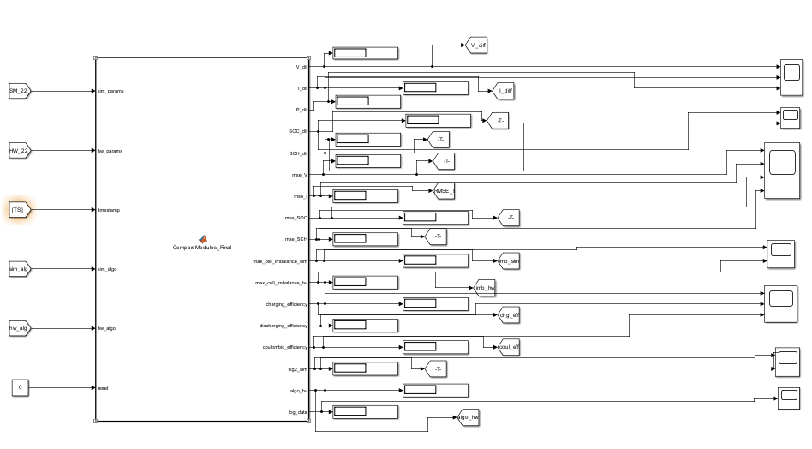
HW SW Comparision code
function [V_dif, I_dif, P_dif, SOC_dif, SCH_dif, ...
mse_V, mse_I, mse_SOC, mse_SCH, ...
max_cell_imbalance_sim, max_cell_imbalance_hv, ...
charging_efficiency, discharging_efficiency, coulombic_efficiency, ...
slg2_sim, algo_hv, log_data] = ...
CompareModules_Final(sim_params, hw_params, timestamp, sim_algo, hw_algo, reset)

% Comparison Block – fixed-size persistent arrays, code-generation ready
% Inputs:
% sim_params : [1x22] vector from simulation branch
% hw_params : [1x22] vector from hardware branch
% timestamp : current simulation time (scalar)
% sim_algo : algorithm code for simulation (scalar)
% hw_algo : algorithm code for hardware (scalar)
% reset : set to 1 to reset accumulated errors (scalar)
%
% Outputs (17 total):
% V_dif, I_dif, P_dif, SOC_dif, SCH_dif : instantaneous differences
% mse_V, mse_I, mse_SOC, mse_SCH : running RMSE
% max_cell_imbalance_sim, max_cell_imbalance_hv : cell voltage spreads
% charging_efficiency, discharging_efficiency, coulombic_efficiency
% slg2_sim, algo_hv : algorithm codes
% log_data : [1x66] vector for CSV logging

% -------------------------------------------------------------------------
% Parameter index mapping (1-based) – MUST match your upstream blocks
% 1:SOC, 2:SOH, 3:SOP, 4:DOD, 5:ROH, 6:RUL, 7:CycleCount,
% 8:V_avg, 9:I_avg, 10:P_avg, 11:stress_idx, 12:aging_rate_frac, 13:energy_kWh,
% 14:degrad_idx, 15:T_idx, 16:health_idx, 17:I_peak, 18:V_min, 19:T_max,
% 20:Ah_charge_total, 21:Ah_discharge_total, 22:overtime_sec
% -------------------------------------------------------------------------

% Extract simulation parameters
SOC_sim = sim_params(1);
SOH_sim = sim_params(2);
RUL_sim = sim_params(6);
Cycle_sim = sim_params(7);
V_sim = sim_params(8);
I_sim = sim_params(9);
P_sim = sim_params(10);
stress_sim = sim_params(11);
health_sim = sim_params(16);
V_min_sim = sim_params(18);
V_max_sim = sim_params(17); % using I_peak as proxy for max voltage
T_sim = sim_params(19); % T_max as temperature proxy
energy_sim = sim_params(13);
charge_sim = sim_params(20) + sim_params(21); % total Ah throughput

% Extract hardware parameters (same indices)
SOC_hw = hw_params(1);
SOH_hw = hw_params(2);
RUL_hw = hw_params(6);
Cycle_hw = hw_params(7);
V_hw = hw_params(8);
I_hw = hw_params(9);
P_hw = hw_params(10);
stress_hw = hw_params(11);
health_hw = hw_params(16);
V_min_hw = hw_params(18);
V_max_hw = hw_params(17);
T_hw = hw_params(19);
energy_hw = hw_params(13);
charge_hw = hw_params(20) + hw_params(21);

% Compute instantaneous differences
V_dif = V_sim - V_hw;
I_dif = I_sim - I_hw;
P_dif = P_sim - P_hw;
SOC_dif = SOC_sim - SOC_hw;
SCH_dif = SOH_sim - SOH_hw;
T_dif = T_sim - T_hw; % for logging only
Cycle_dif = Cycle_sim - Cycle_hw;
RUL_dif = RUL_sim - RUL_hw;
health_dif = health_sim - health_hw;
stress_dif = stress_sim - stress_hw;

% -------------------------------------------------------------------------
% Persistent variables for RMSE (fixed-size circular buffer)
persistent err_V err_I err_SOC err_SOH err_idx max_errors
persistent cum_energy_sim cum_energy_hw cum_charge_sim cum_charge_hw

% Initialize on first call
if isempty(err_V)
max_errors = 10000; % store up to 10000 samples
err_V = zeros(1, max_errors);
err_I = zeros(1, max_errors);
err_SOC = zeros(1, max_errors);
err_SOH = zeros(1, max_errors);
err_idx = 0;
cum_energy_sim = 0;
cum_energy_hw = 0;
cum_charge_sim = 0;
cum_charge_hw = 0;
elseif reset
% Reinitialize when reset is triggered
err_V(:) = 0;
err_I(:) = 0;
err_SOC(:) = 0;
err_SOH(:) = 0;
err_idx = 0;
cum_energy_sim = 0;
cum_energy_hw = 0;
cum_charge_sim = 0;
cum_charge_hw = 0;
end

% Update cumulative values with latest parameters (these are just copies)
cum_energy_sim = energy_sim;
cum_energy_hw = energy_hw;
cum_charge_sim = charge_sim;
cum_charge_hw = charge_hw;

% Store errors only when timestamp advances (and not reset)
if timestamp > 0 && ~reset
err_idx = err_idx + 1;
if err_idx > max_errors
% Circular buffer: discard oldest, keep most recent
err_V(1:end-1) = err_V(2:end);
err_I(1:end-1) = err_I(2:end);
err_SOC(1:end-1) = err_SOC(2:end);
err_SOH(1:end-1) = err_SOH(2:end);
err_idx = max_errors;
end
err_V(err_idx) = V_dif;
err_I(err_idx) = I_dif;
err_SOC(err_idx) = SOC_dif;
err_SOH(err_idx) = SCH_dif;
end

% Compute RMSE from all stored errors
if err_idx > 0
mse_V = sqrt(mean(err_V(1:err_idx).^2));
mse_I = sqrt(mean(err_I(1:err_idx).^2));
mse_SOC = sqrt(mean(err_SOC(1:err_idx).^2));
mse_SCH = sqrt(mean(err_SOH(1:err_idx).^2));
else
mse_V = 0; mse_I = 0; mse_SOC = 0; mse_SCH = 0;
end

% Cell imbalance (using min and max as proxy)
max_cell_imbalance_sim = V_max_sim - V_min_sim;
max_cell_imbalance_hv = V_max_hw - V_min_hw;

% Efficiencies (prevent division by zero)
if cum_energy_hw > 0
charging_efficiency = cum_energy_sim / cum_energy_hw;
else
charging_efficiency = 1;
end
if cum_charge_hw > 0
coulombic_efficiency = cum_charge_sim / cum_charge_hw;
else
coulombic_efficiency = 1;
end
discharging_efficiency = charging_efficiency; % simplified

% Algorithm codes
slg2_sim = sim_algo;
algo_hv = hw_algo;

% -------------------------------------------------------------------------
% Build log_data vector – fixed length 1x66
% Order:
% 1 timestamp
% 2-23 sim_params (22)
% 24-45 hw_params (22)
% 46 V_dif, 47 I_dif, 48 P_dif, 49 SOC_dif, 50 SCH_dif,
% 51 T_dif, 52 Cycle_dif, 53 RUL_dif, 54 health_dif, 55 stress_dif
% 56 mse_V, 57 mse_I, 58 mse_SOC, 59 mse_SCH
% 60 max_cell_imbalance_sim, 61 max_cell_imbalance_hv
% 62 charging_efficiency, 63 discharging_efficiency, 64 coulombic_efficiency
% 65 sim_algo, 66 hw_algo
% -------------------------------------------------------------------------
log_data = [timestamp, ...
sim_params, ...
hw_params, ...
V_dif, I_dif, P_dif, SOC_dif, SCH_dif, T_dif, Cycle_dif, RUL_dif, health_dif, stress_dif, ...
mse_V, mse_I, mse_SOC, mse_SCH, ...
max_cell_imbalance_sim, max_cell_imbalance_hv, ...
charging_efficiency, discharging_efficiency, coulombic_efficiency, ...
sim_algo, hw_algo];

end

------------------------------

Block-by-Block Summary

Module 1 – Simulation Branch
- Block 1 – AC to DC Converter
Converts AC power to DC using a rectifier. Feeds Block 2.
- Block 2 – DC to DC Converter
Buck-boost converter that regulates DC voltage for the battery. Feeds Block 3.
- Block 3 – Load & Battery Controller
Decides when to charge or discharge based on SOC; controls the DC motor load. Feeds Block 4.
- Block 4 – 5×30 Battery Bank (Simulation)
Simulates 150 Li-ion cells (5 modules × 30 cells). Each cell has 3.3 V nominal, with random initial SOC to mimic real imbalance. Feeds Block 5.
- Block 5 – Overall Outputs (Simulation)
Measures pack voltage, current, SOC, and power. Sends these to Block 6.
- Block 6 – AEKF / Li-Mamba Estimator (Simulation)
Runs an Adaptive Extended Kalman Filter (AEKF) or the novel Li-Mamba selective state space model to estimate SOC, polarization voltages, internal resistance, and capacity. Feeds Block 7.
- Block 7 – Parameter Estimation + WOA (Simulation)
Computes 22 battery health parameters from the AEKF outputs. The Whale Optimization Algorithm (WOA) periodically fine-tunes resistance and capacity. Feeds Block 8 and Block 10.
- Block 8 – Pre-training Data (Simulation)
Collects sliding windows of the 22 parameters and extracts 396 multi-scale statistical features. Also generates synthetic anomalies with Gaussian Process Regression (GPR). Feeds Block 9.
- Block 9 – AI/ML/DL Estimator (Simulation)
Uses a transformer-based model (BatteryGPT) or other algorithms (selected by algorithmChoice) to predict SOC, SOH, and RUL from the features. Feeds Block 10.
- Block 10 – AI/ML/DL Predictor (Simulation)
A federated ensemble of five models (Random Forest, XGBoost, LSTM, MLP, Gaussian Process) that fuses predictions and gives calibrated confidence scores. Also outputs the active algorithm code. Feeds Block 19.

Module 2 – Hardware Branch
- Block 11 – Hardware Battery Bank Data
Reads real sensor data (voltage, current, temperature) from the physical battery pack via a DAQ. Feeds Block 12.
- Block 12 – 5×30 Battery Bank (Hardware)
The actual physical battery pack (150 cells). Its outputs go to Block 13.
- Block 13 – Overall Outputs (Hardware)
Collects measured voltage, current, SOC (from external estimator), and power. Feeds Block 14.
- Block 14 – AEKF / Li-Mamba Estimator (Hardware)
Same algorithm as Block 6 but applied to real hardware data. Feeds Block 15.
- Block 15 – Parameter Estimation + WOA (Hardware)
Same as Block 7, computing 22 parameters from hardware measurements. Feeds Block 16 and Block 18.
- Block 16 – Pre-training Data (Hardware)
Same as Block 8, building windows and features from hardware data. Feeds Block 17.
- Block 17 – AI/ML/DL Estimator (Hardware)
Same as Block 9, using hardware features for prediction. Feeds Block 18.
- Block 18 – AI/ML/DL Predictor (Hardware)
Same federated ensemble as Block 10, applied to hardware data. Feeds Block 19.

Module 3 – Comparison & Output
- Block 19 – Comparison Module
Takes the 22-parameter vectors and algorithm codes from both simulation and hardware branches. Computes instantaneous differences, running RMSE, cell imbalance, efficiencies, and logs everything. Outputs a 32-element vector for real-time display and a full log for CSV. Feeds Block 20 and Block 21.
- Block 20 – Output Generation
Sends the 32 display signals to Scopes, Display blocks, and the workspace.
- Block 21 – Cloud Integration
Publishes selected data (e.g., SOC, voltage, errors) to ThingSpeak and updates a Node-RED dashboard for remote monitoring.

The 32 Outputs from Block 19 (for Real-Time Display)
# | Signal | Description
1 | V_sim | Simulated pack voltage
2 | I_sim | Simulated pack current
3 | SOC_sim | Simulated state of charge
4 | SOH_sim | Simulated state of health
5 | T_sim | Simulated temperature
6 | RUL_sim | Simulated remaining useful life
7 | health_idx_sim | Simulated overall health index
8 | V_hw | Hardware pack voltage
9 | I_hw | Hardware pack current
10 | SOC_hw | Hardware state of charge
11 | SOH_hw | Hardware state of health
12 | T_hw | Hardware temperature
13 | RUL_hw | Hardware remaining useful life
14 | health_idx_hw | Hardware overall health index
15 | V_diff | Voltage difference (sim – hw)
16 | I_diff | Current difference
17 | SOC_diff | SOC difference
18 | SOH_diff | SOH difference
19 | T_diff | Temperature difference
20 | RUL_diff | RUL difference
21 | RMSE_V | Running RMSE of voltage
22 | RMSE_I | Running RMSE of current
23 | RMSE_SOC | Running RMSE of SOC
24 | RMSE_SOH | Running RMSE of SOH
25 | imbalance_sim | Simulated cell voltage spread
26 | imbalance_hw | Hardware cell voltage spread
27 | charging_eff | Charging efficiency
28 | coulombic_eff | Coulombic efficiency
29 | algo_sim | Active algorithm in simulation (1–5)
30 | algo_hw | Active algorithm in hardware (1–5)
31 | stress_idx_sim | Simulated stress index
32 | stress_idx_hw | Hardware stress index
These 32 signals are the key novelty indicators of your system – they simultaneously show the performance of both twins, the error between them, and the advanced algorithms at work.

Output Data
